Indonesia
Beyond Genocide: Illumination #11
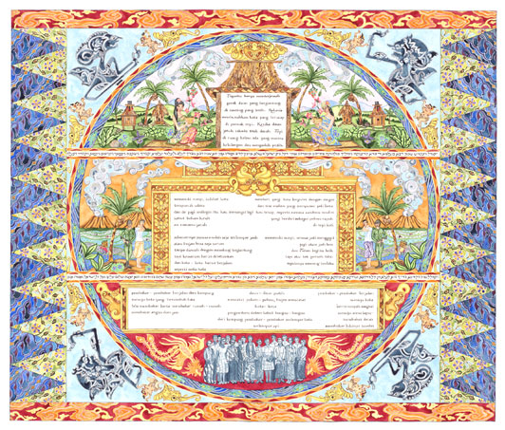

Indonesia
26" x 20" Limited Edition Giclee Reproduction
Indonesia is the 11th illumination included the series Beyond Genocide. This traveling fine art exhibition has been created for loan or purchase for institutions dedicated to education in the fields of genocide history, prevention, human rights issues, transitional justice and peace studies as well as institutions dedicated to contemporary art expressions. Beyond Genocide explores the history and legacy of mass atrocity from critical examples of mass violence from around the planet. Through the beautiful and sacred art of the illuminated manuscript the stories of the victims of mass atrocity emerge as a universal message of remembrance and understanding.
Indonesia explores the Indonesian killings of 1965 - 66; a state sponsored purge of the popular communist organization commonly known as the PKI. Although much remains unknown about the sweep of violence it is estimated that a minimum of 500 thousand people were killed. The Suharto Government's military forces along with vigilante groups targeted victims primarily for political affiliation; but ethnic, religious and cultural hatreds, revenge, racial and social divisions fomented mass executions. This piece also explores the 1975 invasion of island of Timor where an estimated 100 thousand East Timorese were killed as a result of the Suharto regime's military annexation and forced occupation. This illumination draws upon the rich and diverse cultural histories of Indonesia with specific reference to the traditions and cultural expressions originating on the islands of Java, Bali and East Timor. Poetry selections from the era convey a spirit of collective loss as a result of the enforced 40 year silencing of these mass killings.
For more information about hosting or purchasing Beyond Genocide please visit: www.20thcenturyilluminations.com

Our mailing address is:
20th Century Illuminations
236 Neilson Rd.
New Salem, MA 01355

Copyright (C) 2010 20th Century Illuminations All rights reserved.


