International law expert Antonio Cassese dies

Saturday, October 22, 2011
- 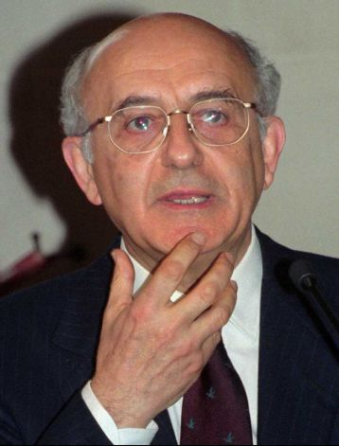
FILE - In this Wednesday, Feb. 21, 1996 file photo, judge Antonio Cassese gestures, in Paris, France. The Special Tribunal for Lebanon says its former president, renowned Italian jurist Antonio Cassese, has died after a long battle with cancer. The court said in a statement Saturday, Oct. 22, 2011, that Cassese died peacefully at his home in Florence on Friday night. His death came less than two weeks after Cassese stepped down as the tribunal's president due to his ill health. Cassese was one of the world's most respected experts in international law. He also served as the first president of the International Criminal Tribunal for the Former Yugoslavia from 1993-97 and led the United Nations' International Commission of Inquiry into Genocide in Darfur in 2004. Photo: Michel Lipchitz / AP

THE HAGUE, Netherlands (AP) — Renowned international law expert Antonio Cassese, who served as first president of the Yugoslav war crimes tribunal and later as president of the Special Tribunal for Lebanon, has died after a long battle with cancer, the Lebanon tribunal announced Saturday.
The court set up to prosecute the assassins of former Lebanese Prime Minister Rafik Hariri said in a statement that Cassese died peacefully at his home in Florence, Italy, on Friday night.

"For members of the tribunal he was the Maestro, whose towering ability as a jurist and a statesman was equaled by the immense personal warmth and humanity which made him our dear friend," said David Baragwanath, who succeeded Cassese less than two weeks ago as president of the Special Tribunal for Lebanon after the Italian stepped down on health grounds.
Cassese was still working as an appeals judge at the tribunal at the time of his death.

Cassese was one of the world's most respected experts in international law. He guided the International Criminal Tribunal for the Former Yugoslavia during its first years of operation, from 1993-97, and led the United Nations' International Commission of Inquiry into Genocide in Darfur in 2004.

[Comment by Genocide Watch: Both the ICTY under Cassese’s Presidency and the International Commission of Inquiry into Genocide in Darfur refused to find specific intent to commit genocide in spite of thousands of deaths directed by government officials in the Serb portion of Bosnia and at least a hundred thousand deaths directed by Sudanese government armed militias and Sudanese Air Force bombing in Darfur. Cassese’s legal conclusions were heavily criticized as having gutted the preventive purpose of the Genocide Convention. It was not until he left the ICTY that it convicted its first defendant of genocide. Only when the International Criminal Court issued an arrest warrant for genocide against President Omar al-Bashir of Sudan were Cassese’s conclusions reversed about the genocide in Darfur.]

Cassese was born in 1937 in Italy. The Lebanon tribunal did not release his exact age.
"He created and was the pre-eminent figure in modern international criminal law," Baragwanath said. "His family extended across the globe to wherever there was injustice. His vision, intellect, dynamism and courage changed attitudes, institutions and lives."

Cassese was professor of international law at the University of Florence from 1975 until 2008 and was a visiting fellow at Oxford University's All Souls College from 1979-80. He published extensively on international law, particularly international criminal law, and received several awards for his work.
Funeral arrangements were not immediately announced.
Read more: http://www.seattlepi.com/news/article/International-law-expert-Antonio-Cassese-dies-2231111.php#ixzz1bbqV6SQe

Copyright 2011 The Associated Press

