Iran turns the screws on dissidents ahead of elections, report finds

By The Telegraph

28 February 2012
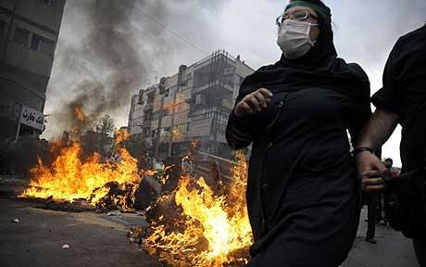
Credit: AFP/GETTY
Iran is desperate to avoid an uprising popular protests like those that flared up after the 2009 elections.

"In Iran today you put yourself at risk if you do anything that might fall outside the increasingly narrow confines of what the authorities deem socially or politically acceptable," said Ann Harrison, interim deputy director of Amnesty's Middle East and North Africa programme.
"Anything from setting up a social group on the Internet, forming or joining a NGO, or expressing your opposition to the status quo can land you in prison," she said.
The report entitled "We are ordered to crush you: Expanding Repression of Dissent in Iran" details repressive acts by the Iranian authorities since February 2011, including a wave of arrests.
The arrests, Amnesty said, have targeted a range of groups including lawyers, students, journalists, political activists and their relatives, as well as religious and ethnic minorities, film-makers and people with international connections, particularly to media.
"This dreadful record really highlights the hypocrisy of the Iranian government's attempts to show solidarity with protesters in Egypt, Bahrain and other countries in the region," Amnesty said.
It said the situation has particularly worsened in the run-up to parliamentary elections due to take place on March 2.
The clampdown has targeted electronic media, seen by the authorities as a major threat, Amnesty said, adding that attacks on dissenting views come against a backdrop of a worsening overall human rights situation in Iran, including public executions used to strike fear into society.
Amnesty called on the global community "not to allow tensions over Iran's nuclear programme or events in the wider region to distract it from pressing Iran to live up to its human rights obligations."
"For Iranians facing this level of repression, it can be dispiriting that discussions about their country in diplomatic circles can seem to focus mainly on the nuclear programme at the expense of human rights," said Ms Harrison.
Tension between Iran and world powers have escalated over Tehran's nuclear programme. World powers suspect Iran is making atomic weapons under the guise of a civilian nuclear programme. Tehran denies the charge.
Iran is holding Friday a parliamentary election, its first national poll since the controversial 2009 re-election of President Mahmoud Ahmadinejad.
A total of 3,444 vetted candidates are vying for the 290 seats in the parliament, known as the majlis, to be decided by an electorate of 48 million voters.
Copyright 2012 Telegraph Media Group Ltd.

