Benjamin Netanyahu invokes Holocaust in push against Iran

By Joel Greenberg, The Washington Post

29 February 2012

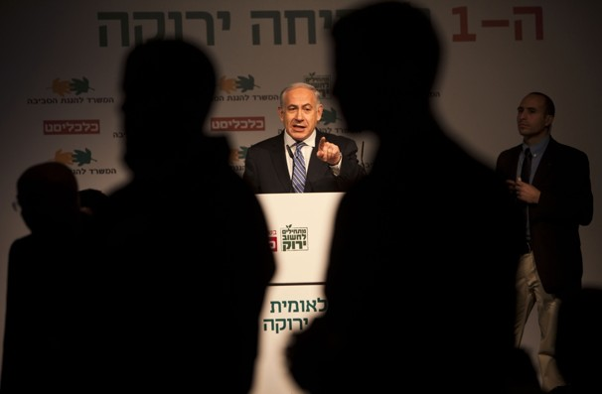
Credit: Oded Balilty/AP - Israeli Prime Minister Benjamin Netanyahu speaks during a conference in Tel Aviv on Tuesday. Netanyahu sets off for a critical U.S. visit next week with a serious rift apparently developing over a possible Israeli military offensive against the nuclear program of archenemy Iran.

JERUSALEM – Addressing a joint session of the U.S. Congress back in 1996, Israeli Prime Minister Benjamin Netanyahu, then in his first term in office, launched into what would become a familiar refrain.
Warning that Iran was trying to acquire atomic weapons, Netanyahu urged the United States to “stop the nuclearization of terrorist states.”
“The deadline for attaining this goal is getting extremely close,” Netanyahu said, adding, “deterrence by itself may not be sufficient. Deterrence must now be reinforced with prevention — immediate and effective prevention. . . .Time is running out.”
Sixteen years later, after tirelessly raising the alarm about Iran’s nuclear program, Netanyahu seems to have finally rallied the West to his cause, successfully thrusting Tehran’s nuclear ambitions to the top of the international agenda. And in his second term as prime minister, he faces what could prove to be the most critical decision of his career, weighing whether to strike Iran’s nuclear facilities, possibly over the objections of his staunchest ally in Washington.
Israel’s next moves, as international sanctions on Iran gather steam, are expected to be the focus of Netanyahu’s planned March 5 meeting with President Obama at the White House.
While Defense Minister Ehud Barak has warned that Iran’s nuclear program could soon enter a “zone of immunity” in which its facilities would be protected underground from military strikes, aides and analysts familiar with Netanyahu’s thinking say he views the problem in more fundamental terms.
They say the prime minister approaches the Iranian challenge with a sense of history and a profound conviction that he is fighting to prevent another Holocaust, a modern-day threat of annihilation against the Jewish state.
Calls by Iranian President Mahmoud Ahmadinejad for the eradication of Israel, his denial of the Holocaust, and his support for militant groups sworn to Israel’s destruction have led Netanyahu to depict him as another Hitler.
“It’s 1938 and Iran is Germany, and it’s racing to arm itself with atomic bombs,” Netanyahu, then the leader of the opposition, told a gathering of Jewish leaders in Los Angeles in 2006.
Addressing a parliamentary session last month marking International Holocaust Remembrance Day, Netanyahu drew a direct parallel. “Seventy years after the Holocaust, many in the world are silent in the face of Iran’s pledges to wipe Israel off the face of the earth,” he said. “This is a day in which the leaders of the world must commit not to allow another genocide.”
Zalman Shoval, a former Israeli ambassador to the United States and long-time adviser to Netanyahu, said that while Iran’s threats were aimed at Israel, the prime minister “is not looking at it only from the point of view of the people of Israel, but from the point of view of the Jewish people in general.”
“Zionism has always looked at Israel as the answer to the dangers facing the Jewish people in the diaspora, and putting Israel in jeopardy raises many profound questions,” Shoval said. For Netanyahu, he added, “the most important consideration is that there is no future for the Jewish people without a state of Israel.”
As he jockeys with Washington, which has urged restraint to allow international sanctions to bite, Netanyahu has stressed that while Israel seeks the support of other nations, it cannot forfeit freedom of action when it comes to self-defense.
In his speech to parliament last month, Netanyahu summoned up the evocative image of a formation of Israeli fighter jets that several years ago flew demonstratively over the site of what was the Auschwitz-Birkenau concentration camp in Poland.
Gallery
“This image says it all,” Netanyahu said. “This image epitomizes the great change in our people’s history: from a people helpless before its enemies to a people that defends itself.
“Ultimately, when it comes to a threat to our very existence, we must not abandon our future to others, Netanyahu said. “When it comes to our fate, we must rely only on ourselves.”
At a recent national security conference near Tel Aviv, defense minister Barak characterized the dilemmas facing him and Netanyahu, the key decision-makers on Iran, as existential choices similar to those that confronted leaders of Israel when the state was born and before the Middle East wars of 1967, when Israel struck preemptively, and 1973, when it was surprised and suffered heavy losses.
Then as now, Barak said, “the essence of leadership is knowing when to act and when to wait,” requiring “the courage to make decisions and carry them out.”
Aluf Benn, editor-in-chief of the liberal daily Haaretz, who covered Netanyahu for years as the newspaper’s diplomatic correspondent, said the prime minister had succeeded in shifting the diplomatic conversation, after the Obama administration had been focused previously on peace efforts with the Palestinians. Then, Netanyahu’s rhetoric on Iran was seen as an effort to divert attention from Israeli settlement building in the West Bank, which was loudly opposed by Washington.
“He did a very good job of changing the world’s priorities,” Benn said, “and he achieved that by saber-rattling vis-à-vis Iran. The problem is that you can reach a point when the political price of not going to war becomes too much to bear. If the Iranian nuclear program is a Holocaust, then the question becomes: What did you do, Mr. Netanyahu, to prevent it? You have to deliver.”
Copyright 2012 The Washington Post

