Attempted Killings Incite Violence in Iraq
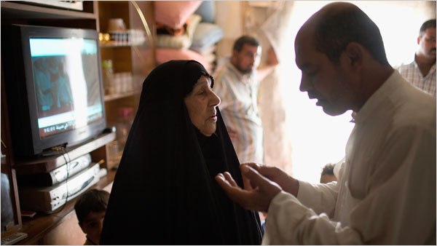
Robert Nickelsberg/Getty Images, for The New York Times
Families that live near the front lines of the fighting in Sadr City have already begun to leave the area in fear of the violence.
By ALISSA J. RUBIN
Published: May 7, 2008
BAGHDAD — Scattered violence struck areas of Baghdad as well as parts of central and northern Iraq on Tuesday, as a trickle of families began to leave Sadr City to escape bombings, and Iraqi security forces raided a hospital suspected of treating militia forces.
In Baghdad, there were clashes in Abu Dshir, a mostly Shiite neighborhood on the city’s southern edge. The tensions were between the Mahdi Army, loyal to the Shiite cleric Moktada al-Sadr, and the National Police. Three civilians were killed and nine were wounded in the fighting. The area had been one of the most violent until late last summer, when it quieted down and the militia put away its weapons.
Prompting the clashes were the attempted assassinations of two dignitaries in Abu Dshir — one a leader in the local Badr Organization, a group linked to the Shiite cleric Abdul Aziz al-Hakim, a rival of Mr. Sadr’s who runs the Islamic Supreme Council of Iraq, and the other the neighborhood’s imam. Although both men survived, the episodes set off fighting between factions loyal to Mr. Hakim and those loyal to Mr. Sadr, said Sayyid Malik Abadi, , the head of Abu Dshir’s security committee.
Two mortar shells exploded Tuesday morning in the Baghdad municipal building, killing three civilians and wounding 15 people. And a rocket landed in Al Mansour University College, wounding five students, according to an official at the Interior Ministry who asked not to be quoted because he was not authorized to speak on the record.
Insurgents often fire mortar shells and rockets toward the Green Zone, headquarters of the Iraqi government and American Embassy, but their misses often harm civilians.
In the Shaula neighborhood, a Sadrist stronghold in western Baghdad, Iraqi forces captured several dozen police officers who were believed to be aiding militia fighters. Some of the officers were captured in a local hospital, which was believed to have been caring for militia fighters, according to a deputy of Qassim Atta, the military spokesman for the Baghdad security plan.
Families have begun to leave Sadr City over the past several days, trickling into the grounds of a sports stadium in Baladiat, which is on the western edge of Sadr City. The families, who lived near the front lines of the fighting and the wall being built by the American military to partition the neighborhood, said they had fled because their children were terrified of the bombing.
As many as 1,500 families are expected to go to the area in the next few days, said Abu Wa’il, the informal mayor of the refugees who live in the area. Some came as recently as two days ago and others have been there for several years, squatting in abandoned buildings. The army will provide tents for the refugees, he said, but there appeared to be no latrines and it seemed doubtful that there would be enough water to supply so many families.
In Tikrit, a car bomb exploded in midafternoon, killing two civilians and wounding 26 people, including four policemen. A curfew was in effect on Tuesday evening.
In Nineveh, an American soldier died after his patrol was attacked on Tuesday, the military said in a statement. In a separate incident in the province, Sunni extremists killed three Iraqi women and wounded two others in an attack on Monday, according to a statement from the American military. The local police said the extremists were members of Al Qaeda in Mesopotamia, the statement said.
Iraqi employees of The New York Times contributed reporting from Baghdad, Tikrit and Diyala.
Copyright 2008 The New York Times Company

