Kirkuk dispute threatens to plunge Iraq into Kurdish-Arab war

Study warns dispute over territories and revenues in oil region could lead to violence greater than Sunni-Shia conflict
- Julian Borger, diplomatic editor
- guardian.co.uk,
- Tuesday October 28 2008 00.05 GMT
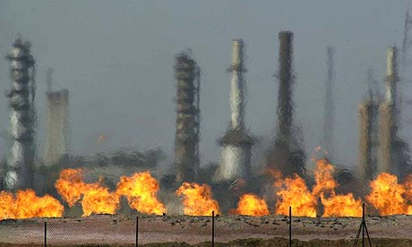
Fires flare off the gas from crude oil at Iraq's oldest oil processing plant in the northern Iraqi town of Baba Gurgur, outside Kirkuk. Photograph: Khalid Mohammed/AP
Iraq's relative calm is threatened by a festering Kurdish-Arab conflict over the oil-rich city of Kirkuk and other disputed territories, that could explode into the worst sectarian war the country has suffered since the 2003 invasion, a new report says today.
The report by the International Crisis Group (ICG) says the territorial dispute is blocking political progress in Iraq, contributing to the delay in passing a law on sharing oil revenue, and threatening to put off critical provincial elections.
Pointing out that the Arab-Kurdish dispute dates back to Britain's creation of modern Iraq after the first world war, the ICG report warns: "In its ethnically-driven intensity, ability to drag in regional players such as Turkey and Iran, and potentially devastating impact on efforts to rebuild a fragmented state, it matches and arguably exceeds the Sunni-Shia divide that spawned the 2005 - 2007 sectarian war."
At the heart of the dispute is the city of Kirkuk, home to 900,000 Kurds, Arabs and Turkmen, which sits on one of the country's biggest oil fields. It lies outside the northern zone run by the Kurdistan Regional Government, but is in practice run by Kurdish peshmerga fighters and a Kurdish intelligence service, the Asaish, which works closely with US intelligence.
Arabs and Turkmen residents, who represent 40% of Kirkuk's population, claim they live in fear, particularly of the Asaish.
The tensions in the city ignited in late July, when a suicide bomber blew himself up in the midst of a Kurdish demonstration. That triggered an attack by a Kurdish mob on the headquarters of a Turkmen party, where guards fired into the crowd. Over 25 people were killed in total and more than 200 injured.
Soon afterwards, Nuri al-Maliki's government in Baghdad sent troops into three areas that had been under informal Kurdish control, further escalating tensions and threatening a direct stand-off between Iraqi regular army and peshmerga forces.
The dispute over Kirkuk has derailed legislation in the national parliament to pave the way for provincial elections. Arab and Turkmen politicians demanded a guaranteed quota of seats in the Kirkuk assembly, but Kurdish parties refused.
Kurdish leaders argue Iraq's constitution gives them the right to absorb Kirkuk and other historically Kurdish-majority areas, in the name of "normalising" demographics skewed under Saddam Hussein by forced removals and a policy of Arabisation.
Today's ICG report recommends that the only solution to the seemingly intractable problem is an "oil-for-soil" trade-off, in which the Kurds are given the right to manage revenues from their own mineral wealth and receive security guarantees for the existing internal boundary between Kurdistan and the rest of Iraq, in exchange for deferring their claims on Kirkuk for 10 years.
The report warns: "The most likely alternative to an agreement is a new outbreak of violent strife over unsettled claims in a fragmented polity governed by chaos and fear."
© 2008 Guardian News and Media Limited

