July 13, 2009

Churches and Envoy Attacked in Iraq
By STEVEN LEE MYERS
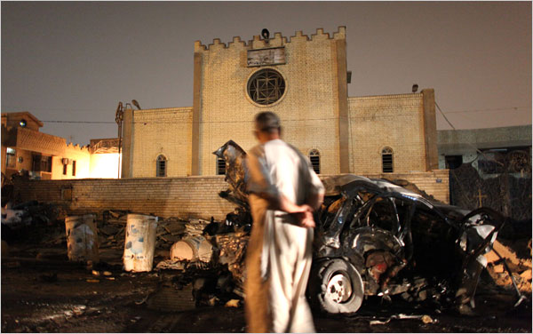
Joseph Sywenkyj for The New York Times
A man stood by damage around the Church of the Virgin Mary in Baghdad, where a deadly car bomb exploded on Sunday.
BAGHDAD — A series of bombings hit five Christian churches here on Sunday, killing at least four people, and the American ambassador to Iraq narrowly escaped injury when a roadside bomb struck his convoy in Nasiriya in southern Iraq.
While there have been attacks on foreign diplomats, including several killings, the bomb in Nasiriya was believed to be the first direct attack on a United States ambassador since the war began in 2003.
“There was a bang, and we went through a thick cloud of smoke,” the ambassador, Christopher R. Hill, told a reporter from USA Today who was traveling in a convoy behind him. “We are all fine.”
The bomb barely missed Mr. Hill’s armored sport utility vehicle and caused minor damage to another one, the newspaper reported.
No one claimed responsibility for the bombing, and it was not clear on Sunday night whether it was intended for Mr. Hill. Adding to a spate of sectarian violence since American combat troops withdrew from Iraqi cities less than two weeks ago, the new attacks raised doubts among many Iraqis about the ability of their own security forces to protect them.
Christians, a beleaguered minority in an overwhelmingly Muslim nation, have routinely faced sectarian attacks, forcing many to flee the country. The bombings on Sunday, though, appeared to be one of the largest single coordinated assaults against churches and Christians in Baghdad.
The attacks began early Sunday with homemade bombs placed near two churches in the neighborhood of Wahda and two others in Dora and Al Gadir, all in eastern Baghdad. They wounded at least 11 people and caused minor damage to the churches.
In the worst attack, a car bomb exploded just before dusk outside the Church of Mariam Al-Adra, or the Church of the Virgin Mary, part of the Chaldean Catholic Church in Iraq, in central Baghdad. The blast, which reverberated across the city, damaged the church and scorched cars near a park on Palestine Street. The blast killed and wounded Christians and Muslims.
“The terrorists don’t distinguish if they were Muslims or Christians,” said Khodor Mohammed, 71, who was wounded in the back, crying as he spoke. “They are killing Iraqis. The blood of Christians and Muslims was mixed today.”
Separately, a senior Christian government official, Aziz Rizko Nissan, was shot and killed by gunmen using weapons with silencers in the volatile northern city of Kirkuk. It was not clear whether Mr. Nissan, who worked in the provincial government’s auditing department, was singled out because of his faith.
“The government does not do anything about these explosions even though the American Army got out of the cities,” Hossain Ali, a college student, said outside the Church of the Virgin Mary. Referring to Iraq’s security services in the heavily secured government zone, he said, “They are just hanging out in the Green Zone and staring at us being killed.”
Even before Sunday’s violence, Iraq’s senior military commander, Lt. Gen. Babakir Zebari, warned that attacks would continue for years, even though he said that insurgents and other extremists were losing ground. He spoke after meeting Iraq’s senior Shiite leader, Grand Ayatollah Ali al-Sistani, in Najaf, the Shiite holy city.
“Terrorists have few strongholds,” General Zebari said, “but they are dangerous. They will seize the chance from time to time to commit attacks. I expect those attacks will go on for the next one, two or three years.”
Sam Dagher and Duraid Adnan contributed reporting from Baghdad, and an Iraqi employee of The New York Times from Najaf, Iraq.
Copyright 2009 The New York Times Company

