July 26, 2009

High Turnout in Iraqi Kurds’ Elections
By SAM DAGHER
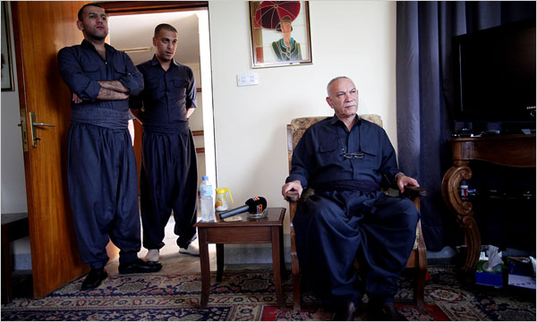
Joseph Sywenkyj for The New York Times
Nawshirwan Mustafa, right, head of the new coalition called Gorran, or Change, that is challenging the two ruling parties in Kurdistan. Mr. Mustafa, with his sons Chia, left, and Nima, wore Gorran's color at home Saturday in Sulaimaniya, Iraq, before leaving to vote.
SULAIMANIYA, Iraq — Voters in Iraq’s semiautonomous Kurdistan region cast their ballots on Saturday in local presidential and parliamentary elections as a hunger for political reform clashed with a desire to maintain stability.
Turnout was high — 78.5 percent according to the Electoral Commission — and voting was extended by an hour to accommodate the crowds.
Preliminary results were not expected until Sunday, but by Saturday night an opposition party was already charging fraud and the governing coalition was claiming a regionwide lead.
There was little doubt here that the governing coalition would maintain its ironclad grip on this region of 4.5 million people. Many Kurds credit the regional government for the relative security and prosperity the region enjoys compared with the rest of Iraq.
“I want to preserve the progress that we have achieved,” said Saada Majid, 42, reflecting the view of many residents as she was being assisted in her wheelchair into a polling station in the working-class neighborhood of Azadi.
The coalition of the Kurdistan Democratic Party, or K.D.P., and the Patriotic Union of Kurdistan, or P.U.K., formerly rivals, controls the region’s government and economic resources, its armed forces and a vast patronage network. And the region’s tense relations with the central government in Baghdad over boundaries and the division of energy revenues bolster a desire for internal unity that also favors the current government.
Still, a challenge mounted by a coalition called Gorran, or Change, while unlikely to seriously dent the government’s majority, added a bracing air of competition to the race and at least the flavor of pluralism.
Security was tight as Kurdish security forces guarded polling places and election workers frisked voters, many of whom wore traditional Kurdish costumes — women in glittering robes, and men in neatly pressed vests and puffy pants held by wide sashes around their waists.
Hours after the voting ended, Gorran issued a statement accusing the two parties of vote rigging and ballot stuffing in Dohuk and Erbil Provinces. An official with the P.U.K. rejected the charge as “unfounded.”
Gorran, headed by Nawshirwan Mustafa, a former P.U.K. insider, hopes to capitalize on disenchantment with the status quo, and a feeling that the two-party monopoly has become autocratic, nepotistic and corrupt.
“They have been in power for 18 years and they have done nothing for the people,” said Faiq Salih, 37, a day laborer from Azadi who said he was voting for Gorran.
As he waited to vote, Mr. Mustafa and his family arrived in a convoy of seven sport utility vehicles bristling with armed guards, and strode into the polling station to be the first to cast their ballots.
“We regard this day as a turning point in contemporary Kurdish political history,” Mr. Mustafa said in an interview earlier at his home. “It is the first time there is such intense demand for change.”
But Gorran was not fielding a presidential candidate, and none of the four who challenged the incumbent president, Massoud Barzani, was thought to have a chance.
Although 23 other parties and coalitions were running against the governing parties in Parliament, the institution is viewed as weak and unlikely to produce significant change. Tariq Fateh, publisher of an antigovernment newspaper, said Gorran would have to win at least a third of Parliament’s 111 seats to make any difference.
Still, even a smaller victory could crack the government’s aura of invincibility, and the government was watching this challenge warily.
“We have shortcomings and we hear them loud and clear,” said Qubad Talabani, the region’s Washington envoy and son of the P.U.K. chairman and Iraqi president, Jalal Talabani. “We know that we cannot have business as usual.”
Mr. Talabani promised that the next government would tackle administrative reforms and corruption, increase transparency and provide better basic services.
Barham Salih, who was to become the region’s next premier if the governing coalition won, also sought to steal Gorran’s thunder.
“We are the real change,” he said in an interview, as aides buzzed around him getting the latest reports from the ground on their telephones.
In accordance with the power-sharing agreement signed between the K.D.P. and P.U.K. in 2005, Mr. Salih of the P.U.K. will give up his post as Iraq’s deputy prime minister and take over as regional premier from Mr. Barzani’s nephew, Nechirvan Barzani.
But already one K.D.P. official was saying that deal could fall apart if the governing coalition lost ground in Sulaimaniya, the base of the P.U.K. as well as Gorran.
The K.D.P. and the P.U.K. fought a bitter civil war in the 1990s but buried their differences to maximize their political gains. Tensions have persisted nonetheless.
Correction: An earlier version of a caption accompanying this article incorrectly identified the politician Nawshirwan Mustafa. While he is the head of a political organization in Iraq’s semiautonomous Kurdistan region called Gorran, he is not a presidential candidate. The caption also misidentified the nature of the organization. Gorran is a coalition, not a party.
Copyright 2009 The New York Times Company

