Double suicide bombs in Iraq town
BBC News
13 August 2009
At least 21 people have been killed by two suicide bombers in northern Iraq, police said.
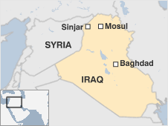
About 30 others were hurt by the attack on a crowded cafe in Sinjar, 390km (240 miles) north-west of Baghdad.
Violence has increased since US troops pulled back from Iraqi cities one month ago, handing security duties to Iraqis.
Earlier this week a bombing in a Shia village near the northern city of Mosul killed at least 28. Eighteen people were killed in Baghdad the same day.
Police and hospital officials told the Associated Press news agency that the cafe in Sinjar was full of young people.
No group has claimed responsibility for the cafe attack.
"These terrorist operations are carried out by al-Qaeda and other groups who do not want to see stability in this area," Sinjar mayor Dakhil Hassoun was quoted by Reuters news agency as saying.
A curfew was imposed by officials in Sinjar, a mainly Yazidi town near the Syrian border.
The Yazidis are an ancient religious sect and there have been a number of attacks on them in Iraq in the past.
In August 2007, some 400 people were killed in the Sinjar area in multiple bomb blasts targeting Yazidis.
Thought to number about 500,000, the Yazidis are to be found in Iran, Russia and Turkey, but the largest number are in northern Iraq.
Their religion is a blend of Zoroastrianism, Islam and other faiths.

