August 16, 2009

Minorities Trapped in Northern Iraq’s Maelstrom
By SAM DAGHER
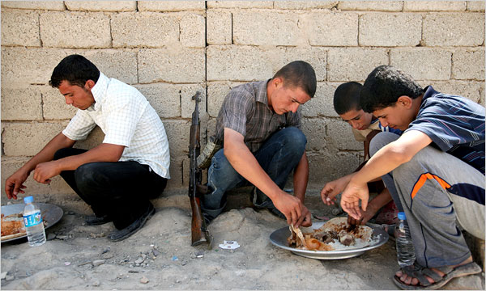
Joseph Sywenkyj for The New York Times
Young men guarding the entrance to Khazna, a village in northern Iraq inhabited by Shiite Shabaks, a Kurdish-speaking minority, taking a break to eat their lunch.
KHAZNA, Iraq — Kamal Ahmed woke up before the crack of dawn and went to the village mosque where he serves as the muezzin.
After calling the people to prayer, he went back to sleep on the roof of his house in a metal post bed covered with a mosquito net, a common practice in Iraq during the sweltering summer months. Minutes later, a huge explosion brought down half of the two-floor house. His side of the house remained miraculously intact, but three members of his family, who were asleep inside, were crushed to death.
Two explosions, which obliterated a large swath of this village of nearly 10,000 people near the northern Iraqi city of Mosul on Monday, killed 34 people and wounded almost 200. The village is inhabited by Shiite Shabaks, a Kurdish-speaking minority.
The attack and others like it — including the suicide bombing on Thursday that killed 21 Yazidis in Sinjar, west of Mosul, and a truck bomb in Shirakhan, just north of Mosul, on Aug. 7 that killed 37 Shiite Turkmen — have underscored how vulnerable minorities continue to serve as fodder for a bigger battle under way in northern Iraq.
The struggle for land, resources and control along a northern strip that has become known as the fault line is festering and threatening hopes of unity among Iraq’s disparate ethnic and religious factions.
“We have three governments up here: the central government, the Kurdish government and the Islamic State of Iraq government,” said an Iraqi soldier from Khazna who spoke on the condition of anonymity for fear of retribution. “We are lost in the middle.”
The central government is trying to push back an expansionist Kurdistan regional government; Sunni Arab leaders have old and new scores to settle with Kurdish leaders; and insurgents linked to Saddam Hussein’s ousted government and Al Qaeda want to foment conflict. All sides appear to be retrenching, shunning compromise or buying time as the withdrawal of American forces looms. Villages like Khazna and minorities like the Shabaks who live on this fault line continue to pay the heaviest price.
Maj. Gen. Robert L. Caslen Jr., commander of American forces in northern Iraq, told reporters on Tuesday that the Sunni insurgent group Al Qaeda in Mesopotamia had now teamed up with another militant group, the Islamic State of Iraq. He said the groups, which have headquarters in northern Iraq, and Mosul in particular, had been behind the attacks in Khazna and Shirakhan.
General Caslen said that despite being “aggressively” pursued by American forces, both groups remained “a resilient force that has the capability to regenerate their combat power as necessary.”
As the villagers of Khazna buried their dead and held funeral wakes, they traded ideas on how best to secure the village. Some said the provincial and central government should do so, while others wanted the protection of the adjacent semiautonomous Kurdistan region. A few said they should start their own village militia, similar to the American-backed Awakening Councils.
At the northern entrance of Khazna, Thulfiqar Mohammed Jaafar, 20, stood guard carrying a battered AK-47 rifle with a taped-together ammunition clip.
Mr. Jaafar said he lost 10 relatives in the attack. He is among a clutch of men, some as young as 15, who are now guarding the village along with the Iraqi police.
In one home, only a single wall remained standing, on which hung a talisman that Shabaks believe protects babies from evil spirits. A cluster of six homes was reduced to rubble with a green Shiite banner, the remnants of a cupboard and shredded blankets.
At least 65 homes were leveled or severely damaged in the two simultaneous truck explosions, villagers said.
“This is mass murder,” one muttered.
Many angry residents claimed that they had evidence that the attack was ordered by Kurdish leaders to compel Shabaks in the Nineveh Plain, a strip of land sandwiched between Mosul and Iraqi Kurdistan, to join the Kurdish region.
Although Kurdish troops have de facto control of the plain, the ultimate fate of these resource-rich territories claimed by both the Kurdish regional authorities and the central government remains in limbo. Sheik Thanoun Wali recalled how two years ago a local Kurdish official dismissed a written request that had been approved by Prime Minister Nuri Kamal al-Maliki to organize a tribal force of 500 men to protect Shabak villages in the plain.
“He put the folder in his drawer and told me, ‘Let the prime minister come and take it out and implement it,’ ” Sheik Wali said. “We are helpless.”
Abdul-Wahed Abdullah, an official in the Kurdistan Democratic Party, which dominates the area, distributed bags of flour, rice and sugar to Khazna’s residents on Tuesday.
Mr. Abdullah said that such a tribal militia would be a recipe for a civil war and that he would stop its creation by force. He said he had already asked his party’s leadership to send additional Kurdish forces to the area to help protect places like Khazna. He said Shabaks were Kurds, not a distinct ethnic group as most of them claimed.
He accused the Hadba coalition, led by Sunni Arabs who came to power in Mosul after January’s provincial elections, of masterminding the Khazna attack.
“They wanted to kill two birds with one stone: kill Shiites and have Kurds blamed,” Mr. Abdullah said.
The Kurds are boycotting the Hadba-led government because it excluded the Kurdistan Democratic Party from all senior posts in the new local administration, even though the party won a third of the provincial council’s seats.
The standoff has become personal. On several occasions, Kurdish gunmen have blocked the Arab governor from entering areas of the province under their control.
The governor, Atheel al-Nujaifi, said last week that he could not protect communities like Khazna unless Kurdish forces were evicted from Nineveh and replaced by government troops.
In an interview in Mosul on Wednesday, a senior Kurdish official dismissed Mr. Nujaifi as “hysterical,” but said American diplomats were trying to broker a solution to the local government crisis in Mosul. It was American pressure that led to a meeting this month between Mr. Maliki and Massoud Barzani, president of the Kurdistan region, to resolve the bigger standoff and acrimony.
All sides may be willing to meet and talk, but no one seems to be interested in making a compromise, at least for now. The devastation that befalls minorities like the Shabak is even used as leverage, said Dildar Zebari, the deputy chairman of Nineveh’s provincial council.
“Everyone is using the blood of citizens for political pressure,” he said.
Thom Shanker contributed reporting from Washington.
Copyright 2009 The New York Times Company

