The Way We Live Now

Vanishing Act
January 13, 2008
By NOAH FELDMAN
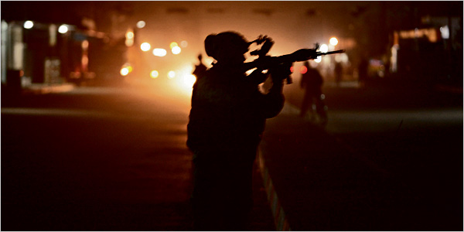
Michael Kamber
What if the United States were at war during a presidential election — and none of the candidates wanted to talk about it? Iraq has become the great disappearing issue of the early primary season, and if nothing fundamental changes on the ground there — a probable result of current policy — the war may disappear even more completely in the new year.
The reasons for Iraq’s political eclipse begin with the unfortunate fact that candidates strive to create feel-good associations, and the war is a certain downer. The film studios could barely get a Middle East movie to break even in the past 12 months (“In the Valley of Elah,” anyone?), and the political image makers have apparently taken note.
Beyond this embarrassing truth, elections demand that candidates differentiate themselves, yet various plausible front-runners’ positions on Iraq are not all that far apart. There are subtle differences regarding the completeness and timing of withdrawal: John Edwards, for instance, says he would remove even the troops who are training the Iraqi Army and police. But basically, the leading doves say they want to leave, but not too fast; while the hawks claim they want to stay, but not too long. One little-noticed consequence of the war’s unpopularity is that, for the first time since the end of the cold war, we are experiencing something that looks very like an unacknowledged consensus between the two parties on the most important question of foreign policy facing the United States.
But the appearance of agreement is built on the absence of disagreement, nothing more. The elites who devised and conducted American policy in the cold war look nonpartisan in retrospect because they were guided by a common realist worldview in pursuing their broadly shared goal of containing the Soviet threat. Today, however, the pseudoconsensus of “leave as soon as we are able, stay as long as we must” rests not on a strategy but on its very opposite: a dodge. At this point, none of the candidates have given detailed, substantive answers to the looming, decisive questions about Iraq that will face the next president the moment he or she takes office.
These questions can be stated with some precision. They begin with the issue of how to interpret the comparative reduction in violence since the surge of United States troops began nearly a year ago. Does the decrease show that more troops on the ground were necessary to impose effective control over territory and persuade insurgents to back down? Or is the reduced violence a sign instead that the prospect of imminent United States withdrawal has made Iraqis more hesitant to foment a civil war from which the United States will not save them? Whatever the answer, the practical consequences are huge: either we keep troop levels relatively stable, drawing down slowly while we consolidate increasing stability, or we accelerate withdrawal to underscore our seriousness about leaving.
There is also the question of what further improvements are possible. Most experts agree that the decline in violence owes a good deal to the efforts of the United States-backed Sunni tribal militias, loosely organized under the name the Sunni Awakening, who have turned against Al Qaeda in Mesopotamia. In theory, it would be nice to know whether these Sunnis are planning to go to war with their Shiite counterparts once we are gone or whether they will use their arms as leverage in efforts to negotiate peacefully. But the answer, in fact, is “both.” The Awakening’s leadership — to the extent that one exists — is prepared for any eventuality.
The rise of the militias on all sides means a future president will have to decide whether the Iraqi state can be salvaged. Are we prepared to accept an Iraq in which tribal leaders rule their localities with little mutual coordination and still less responsibility to the central government? According to one view, the United States cannot shape the local players into a cohesive order regardless of Iraq’s level of killing. The best we can do is calm the worst of the violence, leave and let the Iraqis sort things out for themselves.
An alternative view presumes that state-building has failed so far in Iraq because of the violence. Once the bloodletting has decreased and there are credible negotiators on all sides, a stable Iraq is just barely possible, even if it will never be an exemplar of democracy. Therefore, the theory goes, we should stay in Iraq until the Awakening has — with our prodding and encouragement — organized itself into a unified political force that can engage with the Shiite political parties and create some kind of national settlement.
How our next president handles this difficulty will in turn determine how he or she faces the nightmare prospect of all-out civil war. In case of an actual genocide, do we return troops to Iraq to try to stop the bleeding? In interviews with The New York Times, Barack Obama said yes, while Hillary Clinton seemed to say no. Neither answer fully satisfies: if the genocide is triggered by withdrawal of our troops, it may not be realistic to send them back in; yet inaction invites regional conflagration, not to mention moral bankruptcy. It is very likely any president would use air power to try to separate the sides. But whom do we target? If there are no good guys, do we bomb some civilians to save others?
It is often noted that it can be hard for democracies to fight wars because of changing public opinion. The challenge we face now is what to do when the public has not even been asked what its opinion is. The presidential election is our one chance to put these issues to the democratic test. Otherwise we will be getting a war policy born of neglect — and that will be the policy that we deserve.
Noah Feldman, a contributing writer for the magazine, is a law professor at Harvard University and an adjunct senior fellow at the Council on Foreign Relations.
Copyright 2008 The New York Times Company

