**Building African-Arab connections during Black History Month**

**Khaled A. Beydoun, Abed Ayoub, Al Jazeera**

**08 February 2012**

**The seeds are ripe for a coalition between Arab Americans and African Americans, starting in the city of Detroit.**

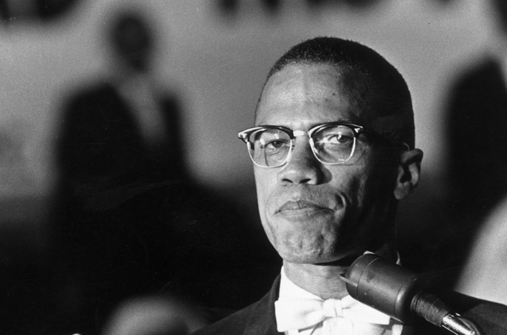***Past leaders like Malcolm X show that Islam has deep roots in the African-American community [GALLO/GETTY]***

Washington, DC - While reflecting upon the transformative contributions and sacrifices made by African Americans should be a yearlong process, Black History Month offers a special opportunity to do so.

It also offers a moment to emulate the courageous and progressive spirit of leaders such as Frederick Douglass, Malcolm X, Rosa Parks and Jackie Robinson.

For Arab America, the month presents an opportune moment to set aside racism for reconciliation, convert boundaries into bridges, and take strides toward building a lasting coalition with the community that blazed the civil rights trail in America. The first step of this journey starts back home - in Detroit.

Detroit is home to the most concentrated Arab-American community in the United States, and the hometown of one of the country's most vibrant and sizeable African-American populations. For decades, these two communities lived among one another but never co-existed within Detroit's hyper-segregated landscape, divided by geographic boundaries and cultural rifts.

Unique significance

Few American cities boast the cultural contributions and historical significance offered by Detroit. The Motown sound was perfected on West Grand Boulevard, while Ford Motor Company revolutionized transportation in nearby Dearborn - today's capital of Arab America. African Americans have called Detroit home for decades, while their once-huddled Arab neighbors fled political and economic despair beginning in the 1970s, seeking the promise of opportunity in Michigan.

Tireman Road demarcates the border separating Arab from Black Detroit on the City's Westside, with little spill over until recently. Warrendale, an enclave of West Detroit, houses a rapidly diversifying population where Arab and African American families live side-by-side. This phenomenon not only offered unprecedented opportunity for genuine cross-cultural interaction, but also the seeds for grassroots coalition building.

Decades later, Manichean divisions pit the two communities at hostile, and sometimes fatal, odds. But a common political experience, whereby Arab Americans face the brand of vilification African Americans have endured for centuries, offers a springboard for meaningful coalition building and co-operation.

The relationship between the two communities still needs work, but there are a number of ripe seeds for future coalescing on the ground, starting with closer co-operation among African-American and Arab-American leadership. Dawud Walid, head of CAIR-Michigan, shares, "I believe that there are better relations between some of the Arab American leaders with some of the African American leaders, post-9/11."

**Building from Islam**

Walid embodies one intersection where Arab Americans and African American can build from - Islam. African Americans comprise more than one-quarter of the Muslim population in the US, whereas the majority of Arab Americans who identify as people of color (and reject the governmental Caucasian designation) practice Islam.

The rising tide of Islamophobia in the US, which vilifies and "others" Muslims of both African and Arab descent, requires the integrated attention and efforts of both communities. A 2011 Pew Study identified Black Muslims to be the "most feared members of the population", signaling that the fight against Islamophobia must be championed by both communities beyond the lines of faith and along the lines of justice.

While Islam is stereotypically conflated with Arabs, African-American Muslim roots reach far deeper. Slaves brought their faith with them across the Atlantic; the Moorish Science Temple Divine and the Nation of Islam were born in the early 20th century to empower marginalized blacks through Islam-inspired spiritualism, and the faith's most prominent Americans, including Muhammad Ali and Malcolm X, are African American, not Arab.

The racialization of Arab Americans, particularly after 9/11, separated young members of the demographic from their racist predecessors. While a critical mass of Arab Americans reject minority status, for reasons along lines of faith, economic or political status, the demonization and marginalization of Arab Americans has shifted a rising majority's affiliation as people of color.

For civil rights

Coalition building with African Americans and other communities, however, must not be inspired by political opportunism, but by a genuine empathy and interest in advancing the interests of civil rights writ large. The worldviews of young Arab Americans, unlike their immigrant predecessors, have been saliently shaped in a post-9/11 world where Arabs emerged into perceived villains, alongside African Americans. Arab racism is gradually being replaced by Arab reconciliation.

Ali Sayed, head of Detroit-based Hype Athletics, manifests the new, race-conscious movement within the young Arab-American community. Hype empowers Detroit area students through athletic and educational mentorship, amid a moment where the city's public schools are decaying. Fifty-nine schools were closed down in 2010, and legislation was passed in 2011 to shutter 70 more through 2014. These measures have had a disparate impact on African-American students, who comprise the vast majority of Detroit Public School's aggregate student body.

Sayed is fully cognizant of this circumstance, and has vigilantly recruited displaced students to enroll in Hype's programming. The organization’s classes bring together the children of Iraqi and Lebanese immigrants with African-American students, whose commonalities extend well beyond a passion for basketball or sports.

"Our kids have many distractions in life, regardless of their race or ethnicity," stated Sayed, a Lebanese American native of Dearborn. "At Hype, we stress togetherness and family, across faiths and especially race."

Therefore, if a meaningful coalition between Arab Americans and African Americans is to be commenced and cultivated, we must first look to Detroit - the capital of Motown, Arab America, and a gradually coalescing African-American and Arab-American community - singular.

***The views expressed in this article are the authors' own and do not necessarily represent Al Jazeera's editorial policy.***

***Source: Al Jazeera***