June 11, 2008

Standing Up for Workers’ Rights in Japan
By MARTIN FACKLER
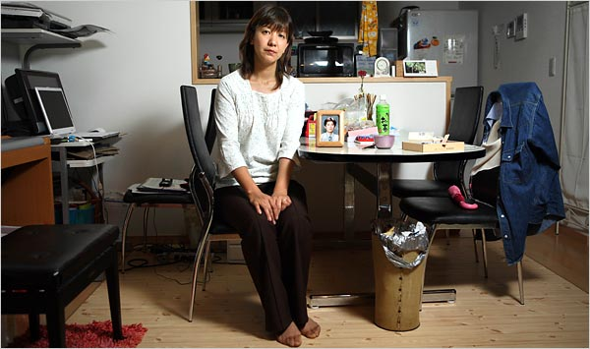
Ko Sasaki for The New York Times
Hiroko Uchino filed a suit against the Japanese government after her husband, a Toyota quality control officer, died at his office.
TOKYO — Japan’s salarymen, famous for their work ethic and their corporate loyalty, fueled this nation’s industrial rise. But more recently, they have borne the brunt of its economic decline, enduring lower wages, job insecurity and long hours of unpaid overtime.
Now, a few are fighting back, like Hiroshi Takano.
For years, Mr. Takano regularly worked into the wee hours as a store manager at the McDonald’s Company Japan. With his health deteriorating and the company, a Japanese business that operates many local restaurants here, refusing to pay overtime, Mr. Takano sued three years ago, and won.
In January, a Tokyo court ordered McDonald’s Japan to pay him $75,000 in back overtime wages. Last month, the company announced it would pay more overtime to store managers.
Slowly and reluctantly, Japan’s salarymen are learning to stand up for their rights, and in the process rewriting the social contract that had once bound workers to companies with near feudal bonds of loyalty. While this renegotiation is still under way, a new generation of Japanese like Mr. Takano is seeking to limit the demands of employers with more American-style legal protections. These changing attitudes reflect a broader shift as Japan, Asia’s first high-growth success story, struggles to mature into a postindustrial economy.
“Japanese are being forced to think more about their self-interest, which is something they are not used to doing,” said Yoichi Shimada, a law professor at Waseda University in Tokyo. “People are slowly realizing there are legal avenues to defend themselves if they feel wronged.”
According to Japan’s Supreme Court, the number of lawsuits filed against employers rose 45 percent from 1997 to 2005, to 2,303 cases. In 2006, that number increased 21 percent, to 2,777 cases if lawsuits heard by a newly created labor arbitration court are included.
Adding to the alienation between employee and company has been a growing sense of resentment that workers have not benefited from the nation’s economic rebound in the last half decade.
While corporate profits have soared, wages have remained stagnant, feeding a perception that companies have failed to share the good times with employees. This has led some to seek a bigger piece of the pie, say legal and labor experts.
There is also a feeling that as companies have cut costs to remain competitive with the cheaper China and South Korea, they passed too much of the burden onto employees. In particular, many of the recent lawsuits involve a practice known as “service overtime,” in which workers were silently pressured into logging long hours of unpaid overtime as a display of loyalty, say labor experts.
“Japanese companies have used the silence of their loyal employees as a weapon in international competition,” said Kiyotsugu Shitara, head of the Tokyo Managers’ Union, a small white-collar union that helped with Mr. Takano’s lawsuit against McDonald’s. “Employees are tired of being used like that.”
Mr. Shitara and other labor experts said the recent rise in lawsuits was also the latest step in a longer-term move toward a more American-style workplace — also apparent in the recent rise in midcareer job hopping, once a rarity here.
Still, many employees involved in the lawsuits describe themselves as reluctant revolutionaries, dragged into a new, more legalistic era to which they have no choice but to adapt.
Some, like Mr. Takano, blame the indifferent attitudes of companies for forcing them to fight back when they would just as soon return to the old, cozy relationship between employer and employee.
“I didn’t want to do this,” said Mr. Takano, 46, who still manages a McDonald’s store in a Tokyo suburb. “The company was treating me too coldly, so I had to start protecting my own rights.”
Another reluctant plaintiff was Hiroko Uchino, who filed a lawsuit against the government after her husband, Kenichi, 30, a quality control officer at Toyota, died at his office six years ago. Ms. Uchino wanted a government labor agency to legally recognize that he had died from overwork, something so common that there is a Japanese word for it, karoshi.
She took legal action after the company said her husband’s death was not because of overwork, and that he had only worked about 38 hours of overtime in January 2002, the month before he died. She said the company ignored her when she tried to submit gas station receipts and other evidence to show he had worked much longer hours: 155 hours that January, by Mr. Uchino’s calculation. She said the company said he stayed after work voluntarily, and was not entitled to overtime pay.
Despite her outrage, Ms. Uchino could not bring herself to legally challenge the auto giant, which dominates the central city of Nagoya, where she lives, and had employed not only her husband but his father and grandfather before him. She sued the labor agency instead to receive more of his overtime pay.
Ms. Uchino’s case won wide sympathy, including a meeting with the labor minister, who gave her words of support. In March, a court in Nagoya ruled her husband’s death had been work-related, and that he had worked 93 hours of overtime in his final month, entitling his widow to additional overtime pay. Toyota had no comment on the case.
“His father would never have turned to the courts, no matter what,” said Ms. Uchino, 38. “But Toyota never would have treated him this way, either. These days, all the company talks about is reducing expenses.”
She added, “If my husband had known how the company would react, he never would have shown all this fruitless loyalty.”
Mr. Takano, the McDonald’s manager, said he had been working from 6 a.m. to 1 a.m. managing two stores before his lawsuit, in some cases seven days a week. McDonald’s Japan said that as a white-collar manager he was not entitled to overtime pay. After a doctor warned him he was at risk of a stroke, Mr. Takano said he had wavered on whether to file a lawsuit — he liked McDonald’s and wanted to keep his job. Now, he hoped the case would improve working conditions for all managers.
The company had no comment on the case.
After the court victory, four other former McDonald’s store managers filed a similar suit demanding pay for overtime pay. Legal experts say more could come throughout the fast-food industry.
“I want Japan to become a society where employees can sue their own company,” Mr. Takano said. “That’s why I’m doing this.”
Copyright 2008 The New York Times Company

