Second Lawmaker Is Killed as Kenya’s Riots Intensify
February 1, 2008
By JEFFREY GETTLEMAN
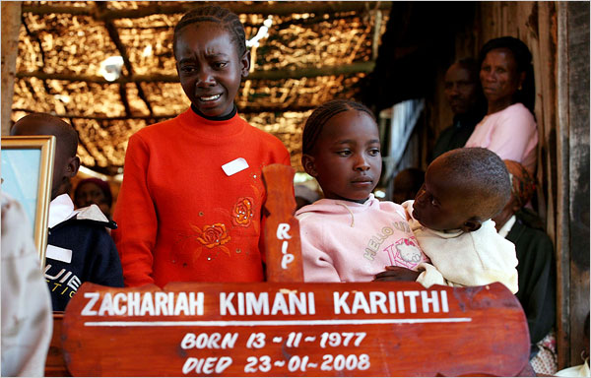
Joao Silva for The New York Times
In Limuru, mourners gathered in memory of a man killed in ethnic fighting that has intensified since an opposition leader’s killing.
NAIROBI, Kenya — A second Kenyan opposition lawmaker was shot dead on Thursday, and riots immediately exploded in opposition strongholds, putting the country increasingly on edge.
The lawmaker, David Kimutai Too, a former teacher from the volatile Rift Valley, was gunned down by a policeman in Eldoret. Kenyan government officials were quick to say the killing was a “crime of passion” connected to a love triangle. Opposition leaders called it an assassination.
“How can police call this an ordinary murder before any investigations?” said William Ruto, an opposition leader. “There is nothing ordinary about having two members of Parliament killed like this.”
Political negotiations brokered by Kofi Annan, the former United Nations secretary general, were halted on Thursday because of the shooting, and the current secretary general, Ban Ki-moon, said he would travel to Nairobi on Friday to address the crisis.
Mr. Too was the second member of the Orange Democratic Movement, Kenya’s main opposition party, to be killed this week. It seemed that the bloodletting began after deeply flawed elections in December, claiming more than 800 lives, appears to be pushing Kenya closer to the brink of disaster.
A shock wave of outrage and panic moved across the country as the news of Mr. Too’s death spread. In Kisumu, an opposition stronghold in western Kenya, mobs of young men tore through the streets, burning tires, throwing rocks and blockading roads. Some carried gasoline bombs and vowed to burn down the police station.
The rioters did not appear to accept the government’s explanation of the killing. It seemed that even if Mr. Too’s death had nothing to do with the volatile political situation here, it was bound to be interpreted as being politically motivated, especially coming so soon after the killing of another opposition lawmaker.
“We won’t believe what they say,” said a protester armed with a rock-hurling sling in Kisumu. Referring to Mwai Kibaki, the Kenyan president, he said: “We know the government is involved. Kibaki’s government will never work in Kenya. We will paralyze this country even if they kill our leaders.”
In Eldoret, shopkeepers shuttered their stores and people dashed home. Protesters massed at the police station, and truckloads of paramilitary officers arrived in town. Hospital officials said the police shot 10 people, killing one. Many people feared reprisal killings in the night.
Police officials in Nairobi, the capital, tried to defuse the situation by quickly announcing that Mr. Too’s killing was in no way political, that officers had arrested the culprit and that he would face murder charges.
According to police officials and witnesses, Mr. Too, who friends said was 39 or 40, spent the morning with Eunice Chepkwony, a policewoman who was dating another police officer, Andrew Moache. Mr. Too and Ms. Chepkwony were driving near the woman’s house on the outskirts of Eldoret when Mr. Moache pulled up next to them on a motorcycle. The police said Mr. Moache had suspected that his girlfriend was seeing someone else and was enraged to find her with another man.
Witnesses said that Ms. Chepkwony jumped out of the car to beg Mr. Moache not to kill them. He shot Ms. Chepkwony in the stomach and Mr. Too in the head several times. Mr. Too died instantly. Ms. Chepkwony bled to death in a hospital a few hours later. The police said they later arrested Mr. Moache as he tried to flee.
“I urge people to remain calm and await the law to take its course,” said a statement issued by a police spokesman, Eric Kiraithe.
But Mr. Too’s ethnicity, Kalenjin, is not likely to help the situation. Kalenjins have overwhelmingly supported Kenya’s opposition leaders, like Mr. Ruto and Raila Odinga, the opposition’s presidential candidate, who narrowly lost the election. More than any other group, Kalenjins have mobilized since the election to attack ethnic groups that have backed President Kibaki.
Minutes after Mr. Kibaki was declared the winner on Dec. 30, amid widespread evidence of vote rigging, bands of young Kalenjin men swept across the countryside killing Kikuyus, Mr. Kibaki’s ethnic group, and burning their homes. In one attack, a Kalenjin mob burned a church, killing as many as 50 people hiding inside. Most of them were Kikuyu women and children.
Several Kalenjin elders and men who have taken part in the attacks have been unapologetic, saying that the violence is part of an organized plan to drive Kikuyus from the Rift Valley, which Kalenjins consider their ancestral land. Tens of thousands of Kikuyus have indeed left. On Wednesday, Jendayi E. Frazer, the assistant secretary of state for African affairs, called the situation ethnic cleansing.
African leaders have been shocked by what has happened to Kenya, which until recently was celebrated as one of the most stable countries on the continent. Paul Kagame, the Rwandan president, said this week that Kenya’s military should forcefully step in before the country goes too far down the road toward another Rwanda. That country exploded in ethnic violence in 1994, with 800,000 people killed.
On Thursday, Alpha Oumar Konaré, chairman of the African Union commission, said: “Kenya is a country that was a hope for the continent. Today, if you look at Kenya you see violence on the streets. We are even talking about ethnic cleansing. We are even talking about genocide.”
Mr. Konaré, speaking at an African Union meeting in Ethiopia, added, “We cannot sit with our hands folded.”
Mr. Ban was also at the meeting and said he was traveling to Kenya because he was increasingly concerned. “Violence continues, threatening to escalate to catastrophic levels,” he said.
Last week, the African Union dispatched Mr. Annan to Kenya to broker a political compromise between the government and the opposition. Each side claims to have won the election, and so far each has refused to back down.
Mr. Ruto, the opposition leader, said talks were going “O.K.” on Thursday until they ended midday because of Mr. Too’s killing.
Neither of the opposition lawmakers killed this week was especially prominent. Both were just weeks into their new jobs as national politicians. Opposition leaders, however, say that is not the point. The opposition holds a slight edge in Parliament, and its leaders contend that the government is trying to reduce their numbers, an accusation it denies.
On Tuesday, Melitus Mugabe Were, a lawmaker and businessman who grew up in a slum, was shot to death in his driveway by two gunmen. The police are closely investigating the killing, but Mr. Were’s friends and family say he was not robbed and that the killing was a professional hit.
Mr. Too a school headmaster from Kericho in central Kenya. He represented a mostly rural area of lush tea farms. He was an underdog candidate, emerging from a field of 13.
“He was a very humble, quiet man,” said Charles Keter, a member of Parliament from a neighboring district.
Reuben Kyama contributed reporting from Nairobi, and Abisalom Omolo from Kisumu.
Copyright 2008 The New York Times Company

