U.S. Envoy Wants Political Pact in Kenya
January 24, 2008
By JEFFREY GETTLEMAN
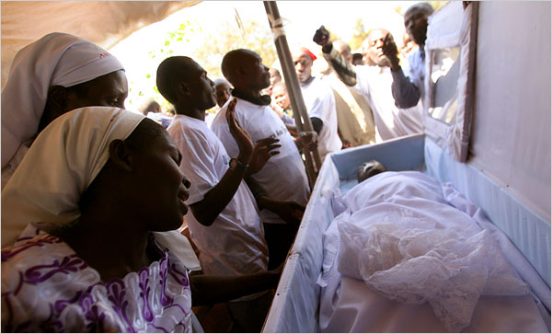
Uriel Sinai/Getty Images
A mass funeral on Wednesday for victims of clashes in Nairobi was marred by disturbances.
NAIROBI, Kenya — The American ambassador to Kenya said Wednesday that his deepest worries about the postelection crisis here were not about Kenyans rampaging in the streets or killing one another because of ethnic hatreds, both of which have claimed hundreds of lives.
Possibly even more dangerous, he said, were the deep rifts among the country’s opposing politicians, who seem “entrenched” and surrounded by “hard-liners.”
“You can never underestimate the ability of just a couple of people to tear a place apart,” said Michael E. Ranneberger, the ambassador, during an interview at his home in Nairobi, the capital.
He said his chief concern was whether Mwai Kibaki, the president, and Raila Odinga, the top opposition leader, were “prepared to rise above themselves and put the interests of the nation ahead of their own personal or their group’s political interest.”
“That is still an unanswered question,” he said.
The politicians need to sit down and compromise, the ambassador added, because “we’re in the middle of a very serious crisis.”
It has been four weeks since Kenyans went to the polls in record numbers, and the country is still reeling from the aftershocks of a disputed tally in which Mr. Kibaki was declared the winner over Mr. Odinga, despite widespread evidence of vote rigging. The Kenyan government has said that more than 650 people have been killed, though Western diplomats and aid workers say the death toll is several hundred higher.
On Wednesday, Kofi Annan, the former United Nations secretary general, met with Mr. Odinga and persuaded him to call off another round of protests that had been scheduled for Thursday. Mr. Annan was also supposed to meet with Mr. Kibaki, but the president postponed the get-together until Thursday and chose instead to meet with Yoweri Museveni, Uganda’s president and a close political ally who is pushing his own peace plan.
So far, Mr. Kibaki and Mr. Odinga have said they are willing to negotiate, but neither has offered substantial concessions, despite pleas from Kenyans and other African dignitaries. The two men have yet to talk face to face.
Mr. Annan, who arrived on Tuesday, seems to have created more buzz and hope than any visitors involved in the previous mediation efforts.
“I think everybody knows that if this mission fails, there are no others in the offing,” said Salim Lone, a spokesman for the opposition. The stakes are clearly high. Killings driven by ethnic strife continue in the Rift Valley, one of Kenya’s most scenic provinces but also the most violent because of historic tensions over land that have been ignited by the election controversy. On Wednesday, two more people were killed there by poison arrows.
In Nairobi, street clashes are becoming the norm. A funeral on Wednesday degenerated into a riot. Opposition protesters pelted cars with stones and set a government building on fire. Last week, protesters sabotaged a crucial railway line running to Uganda. It is still out of commission.
The violence has been a mix of ethnically driven killings, fighting in Nairobi’s slums and battles between the police and protesters. Mr. Ranneberger, who has been ambassador here for about a year and a half, said he was “outraged” when he saw television reports last week showing what appeared to be a police officer shooting an unarmed demonstrator. The protester had been dancing in the street and making faces when one officer leveled an assault rifle and shot him at close range. The officer, who is under investigation, was then shown on television kicking the protester, who later died.
Mr. Ranneberger said the fighting, even in the Rift Valley, was not purely ethnic but “politically, economically and socially motivated,” stemming from tensions over land and the perception that Mr. Kibaki’s ethnic group, the Kikuyu, had marginalized others. He said the violence in the Rift Valley after the election appeared to have been organized because of the involvement of large numbers of heavily armed men who seemed to strike just minutes after the disputed results were announced.
Mr. Ranneberger said the American government, which gives more than $600 million in aid to Kenya annually, was frustrated at the political impasse but was not at the stage where it was ready to cut assistance.
“It’s counterproductive,” he said. “And it’s way too premature to talk about anything punitive.”
The way forward, he said, was for the Kenyan government to be more inclusive and to address the long-simmering grievances over economic and political inequality. He also said officials should investigate the postelection violence and fix Kenya’s election system, which has been badly discredited by the balloting on Dec. 27.
“I really am fundamentally optimistic about the future of the country,” he said, citing Kenya’s strong middle class, its high literacy rates and its independent media. “There are all sorts of reasons why Kenya can overcome this.”
Copyright 2008 The New York Times Company

