Kenya’s Political Rivals Meet
January 25, 2008
By JEFFREY GETTLEMAN
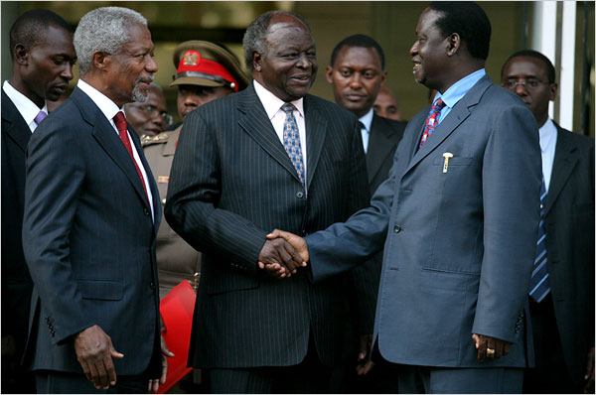
Evelyn Hockstein for The New York Times
President Mwai Kibaki, center, with his rival, Raila Odinga, right, and Kofi Annan, their mediator, in Nairobi on Thursday.
NAIROBI, Kenya — For the first time since Kenya plunged into postelection chaos four weeks ago, the nation’s warring political leaders met face to face on Thursday, but afterward opposition leaders accused the president of being a fraud.
President Mwai Kibaki, who won re-election by a suspiciously thin margin, and the top opposition leader, Raila Odinga, who says the election was rigged, talked for about an hour in Mr. Kibaki’s office. It was just the two of them, along with Kofi Annan, the former United Nations secretary general, who is overseeing the negotiations.
The chat went fine, opposition leaders said, and was mainly an ice-breaker to start a long process of negotiation. But Mr. Kibaki stirred up tempers with a short speech afterward.
Mr. Kibaki pointed out that he was “the duly elected president” and emphasized that any reconciliation would be on his terms. “I will personally lead our country in promoting tolerance, peace and harmony,” he said.
These comments seemed to drain the enthusiasm from the moment, and opposition leaders immediately called a news conference to criticize the president.
“True to his fraudulent character, Mr. Mwai Kibaki abused the occasion by attempting to legitimize his usurpation of the presidency,” opposition leaders said in a statement.
Salim Lone, an opposition spokesman, added: “This was supposed to be an event to build good faith. Kibaki politicized it.”
Mr. Kibaki’s spokesman did not return calls for comment.
It seems that the much-anticipated talks are falling victim to the same cycle of action and reaction that has sent Kenya into a tailspin since the elections, on Dec. 27. Since then, more than 650 people have been killed and 250,000 driven from their homes in a burst of violence that has ethnic and socioeconomic roots but has been fueled by politics.
The talks were supposed to be a breakthrough moment, and maybe they will prove to be. For weeks, Western diplomats and African leaders had been urging the two sides to meet, which they had refused to do.
But clearly the political standoff is not over. Western diplomats have warned that both sides are still far apart and that Mr. Kibaki and Mr. Odinga are surrounded by entrenched backers who do not seem inclined to give an inch.
Both men claim to have won the election. Numerous election monitors have said there were so many irregularities, especially in counting votes, that it is impossible to tell who really won.
Mr. Odinga is demanding a new election and wants to be an equal partner in a transitional government. Mr. Kibaki has rejected those demands, indicating that the most he is willing to offer is a few minor cabinet posts. He has already made appointments to the most powerful posts.
On Wednesday, Michael E. Ranneberger, the American ambassador to Kenya, warned that any dialogue could be slow and difficult. “What the end result of that process of dialogue is going to be, I think it’s just too early to tell,” Mr. Ranneberger said. “There are really a number of hard-line people on both sides. And frankly it’s not clear what the president’s and what Raila Odinga’s real bottom lines are at this point.”
Mr. Annan used his influence and diplomatic seasoning to corral Mr. Kibaki and Mr. Odinga into at least meeting each other. The plan for moving forward is for their lieutenants to hammer out a framework over the next few days that will cover all the issues to be discussed.
Peace advocates in Kenya said any meeting was better than none. “It’s a good beginning,” said George Wachira, a member of a group called Concerned Citizens for Peace. “Symbolically, it sends the right message. If people feel this is going to be resolved at a political level, people will realize there is no need to keep fighting in the streets.”
The worst fighting has been in the Rift Valley Province, where local elders and possibly higher-ranking politicians seem to have organized mobs of young men to attack along ethnic lines.
Several elders and young men who took part in the Rift Valley killings have admitted that they held meetings shortly after the election and plotted to burn homes and hunt down members of rival ethnic groups. Most of the perpetrators were supporters of Mr. Odinga and members of the Kalenjin ethnic group. Most victims were members of Mr. Kibaki’s group, the Kikuyu, who largely voted for the president.
On Thursday, Human Rights Watch said that “opposition party officials and local elders planned and organized ethnic-based violence in the Rift Valley.”
Human Rights Watch said the attacks “could continue unless the government and opposition act to stop the violence.” On Thursday, police reports indicated that at least another 10 people had been killed.
Mr. Kibaki’s allies have accused opposition leaders of ethnic cleansing. Opposition leaders have denied that, saying the violence was spontaneous outrage at the election being stolen.
Reuben Kyama contributed reporting.
Copyright 2008 The New York Times Company

