Vengeance Reignites Kenyan City
January 29, 2008
By JEFFREY GETTLEMAN
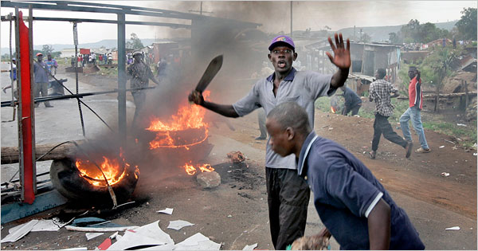
Ben Curtis/Associated Press
Men armed with machetes and rocks at a makeshift roadblock in Kisumu, Kenya, where rioters rampaged Monday, apparently in revenge for the killing of 19 people in a house fire on Sunday.
NAIROBI, Kenya — Kisumu, Kenya’s third largest city, erupted again on Monday as thousands of rioters tore through the streets, burned down stores, looted schools and vented their outrage over a spate of ethnically driven killings over the weekend.
It seems that what started out last month as a political crisis has increasingly turned into a violent ethnic one, fueled by longstanding tensions over land, economic opportunity and access to power. Kenya’s security forces seem to be struggling to keep it from getting worse.
Early Tuesday, in an attack likely to add to the unrest, two gunmen shot and killed an opposition member of Parliament, Mugabe Were, as he drove up to his house in suburban Nairobi just after midnight, the police said, according to The Associated Press.
“We are treating it as a murder, but we are not ruling out anything including political motives,” said Eric Kiraithe, a police spokesman. “We are urging everyone to remain calm.”
The trouble in Kisumu began at 8 a.m. on Monday, when young Luo men set fire to a bus believed to have Kikuyu owners. Witnesses said that the passengers escaped and that the attackers had been exacting revenge for what happened the day before, when a Kikuyu mob trapped 19 Luos inside a house in the town of Naivasha and burned them to death.
By 2 p.m., thousands of rioters were sweeping across Kisumu, lighting enormous bonfires and looting shops and even schools. Witnesses said a mob had cleaned out one primary school, taking desks, chairs, books, doors and even windows. Kenyan television stations showed dozens of terrified children running out of the school, some holding hands, as the mob closed in.
Kisumu, a stronghold of Kenya’s opposition movement, was gutted by furious mobs in late December, when deeply flawed elections set off widespread riots. “Things are really bad again,” said Jacob Otieno Obiero, a Kisumu resident, on Monday afternoon. “There are fires everywhere.”
Police officers fired tear gas at rioters, and residents said officers shot several people with assault rifles, killing four. Witnesses said that gangs of Luos, the ethnic majority in Kisumu, were prowling certain neighborhoods looking for Kikuyus to kill. Many Luos and Kikuyus have been at one another’s throats since Dec. 30, when Kenya’s election commission declared the incumbent president, Mwai Kibaki, who is Kikuyu, the winner over Raila Odinga, an opposition leader who is Luo. Western observers have said there were so many problems with the vote-counting that it is impossible to tell who really won.
Since the election, more than 750 people have been killed and 300,000 displaced.
Much of Kenya is pulling apart along ethnic lines. In neighborhoods and towns that used to be mixed, attackers of the majority ethnic group are driving out others. The result is one homogeneous zone after another, often marked by blackened, empty homes.
On Monday morning, Luos and Kikuyus faced off in Naivasha, with a thin line of police officers separating hundreds of angry young men shaking machetes, iron bars and splintery lengths of wood at one another. It seemed that the police, in this case, were eventually able to disperse the crowds before they killed anyone.
Local news reports, however, indicated that at least 15 people had been killed in ethnic fighting in the Rift Valley since Sunday night.
The most vicious clashes have been in the Rift Valley province, which has several ethnic communities, including Luo, Kikuyu and Kalenjin. The area is better known for its expensive lodges and priceless views, but in the past month it has become a battle zone.
Nairobi, the capital, has been relatively calm this past week, but many Kenyans fear that any multiethnic area could explode at a moment’s notice.
That almost happened on Monday in Gilgil, a small town between Naivasha and Nakuru. Residents said hundreds of young Kikuyus mobilized to drive out Gilgil’s small Luo community. Elders persuaded them to back down, but only after many of the Luo residents agreed to pack up their things and leave.
“In the absence of those people, nothing will happen,” said Moses Gitongah, a Gilgil businessman and chairman of the town’s peace committee. “But it’s very tense.”
Many Kenyans had hoped that an hourlong meeting and a quick handshake last Thursday between Mr. Kibaki and Mr. Odinga would cool things down. But the convulsion of violence in the Rift Valley has dimmed those hopes, and the two sides are still negotiating over negotiating.
Kofi Annan, the former United Nations secretary general, has been in Kenya for nearly a week trying to broker a political compromise. On Monday, opposition leaders and government officials met separately to discuss Mr. Annan’s proposed framework for talks, which may begin later this week.
American officials seem to be increasingly concerned. Congressman Donald M. Payne, Democrat of New Jersey, the chairman of the House Africa subcommittee, is backing a resolution that calls for the United States to apply sanctions against Kenyan politicians “who refuse to engage in meaningful dialogue to end the current crisis.”
Copyright 2008 The New York Times Company

