CRIMES AGAINST HUMANITY

The kényane opposition lodges a complaint in the CPI
NOUVELOBS.COM ¦ 06.02.2008 ¦ 20:40

She accuses the government of Kibaki of crimes against humanity in the repression of demonstrations(appearances) organized by the opposition.
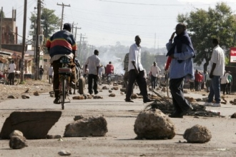
Kisumu, the third city of Kenya and bastion of the opposition to the president taking(bringing) out Mwai Kibaki ( Reuters)

The kényane opposition lodged a complaint to the international penal Court ( CPI) against the government of the president Mwai Kibaki by accusing it of crimes against humanity in the repression of demonstrations(appearances) organized by the opposition, announced, on Tuesday, January 22nd, a spokesman of the opposition. According to the official results(profits) of the election of December 27th, taking(bringing) out him(it) Kibaki was reelected for a second mandate of five years, during the tightest presidential elections of the history(story) of Kenya. His rival, the leader of the opposition Raila Odinga denounces(cancels) a manipulation of the results(profits). The violence which burst since the ballot made at least 685 deaths, according to figures communicated on Tuesday by the government.
Foreign and local observers denounced(cancelled) profound irregularities of the ballot, while the leader of the electoral committee(commission) which had proclaimed the victory of Mwai Kibaki then told to have undergone the pressures and to assert that he ignored who had taken away(gained) the ballot.
Dispersal
Besides, the kényane police scattered on Tuesday in the teargas several tens of partisans of the reelected president Mwai Kibaki collected in the center of Nairobi, at some hours of the arrival in the country of the former(ancient) UN Secretary-General Kofi Annan, who has to tempt a mediation. " Kibaki is our president ", chanted the demonstrators before being scattered by the anti-revolt strengths.
While the international efforts of mediation gave nothing up to here, the former(ancient) General Secretary of United Nations Kofi Annan was waited on Tuesday evening to try to move closer to the parts(parties). (With AP)

