U.S. Intensifies Efforts to End Deadly Conflict in Kenya
February 8, 2008
By JEFFREY GETTLEMAN
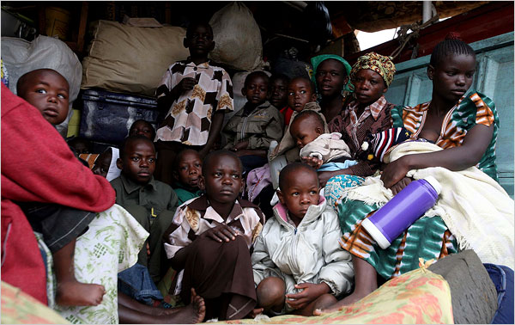
Joao Silva for The New York Times
Members of an ethnic Luo family waited Thursday in a truck at a camp for the displaced in Nakuru to go to their ancestral home.
NAIROBI, Kenya — The American government is playing an increasingly active role in trying to restore peace in Kenya, holding hearings in Washington on Thursday and threatening to prohibit some Kenyan politicians from entering the United States.
A spokesman for the American Embassy in Kenya said Thursday that the embassy had written to 10 politicians and businessmen warning that they and their relatives would be denied entry into the United States if the embassy determined that they had instigated or taken part in violence.
More than 1,000 people have been killed in Kenya since a disputed election in December, and human rights groups have said much of the violence was organized. The American Embassy is warning people in the government and the opposition, and is trying to use the issue of visas to press the leaders to act responsibly and support efforts to reach a political compromise.
“We consider the violence as the most immediate issue to deal with,” said T. J. Dowling, the embassy spokesman. “We wanted to let these people know that we are scrutinizing their acts and we will take action accordingly.”
On Thursday, the Senate held hearings into the underlying causes of the unrest and how it affected other countries in the region. Until December, Kenya was known as an anchor state in East Africa, and it remains a base of operations for extensive aid efforts in some of its more turbulent neighbors, like Somalia, Sudan and Congo. The House of Representatives held similar hearings on Wednesday.
“Kenya is an important partner for the United States,” said Russ Feingold, Democrat of Wisconsin and chairman of the Senate’s subcommittee on African affairs, in a statement. “But the lack of progress in addressing a number of deep-rooted problems, including political marginalization, land disputes and endemic corruption, appear to have taken a toll. By many accounts, the situation in Kenya could still get much worse.”
The American government has temporarily removed nearly 150 Peace Corps volunteers from Kenya. American officials said that even though Americans had not been the targets of attacks, the continuing instability, which included mob killings and roadblocks across the country, had made it dangerous for the volunteers to remain at their rural posts.
The Kenyan government seems to be swinging into action as well. On Thursday, police officials announced that they were charging an officer with murder in the shooting of an unarmed protester.
Eric Kiraithe, a spokesman for the Kenyan police, said the government had arrested the officer, who was shown on Kenyan television last month shooting a protester at close range, then kicking him in the ribs with combat boots. The protester was unarmed and had been dancing and making faces. He later died. The same police officer has also been charged in the shooting death of another unarmed protester at the same demonstration.
Police officials were quick to note that the officer was from the Kalenjin ethnic group, which tends to support the opposition.
“This appears to be a clear case of criminal misconduct,” Mr. Kiraithe said. “It has nothing to do with tribe.”
Police officers have also arrested more than 20 men this week on suspicion of terrorizing women in Naivasha, where mobs recently killed dozens of people. The men have been accused of molesting and attacking women who wore pants instead of skirts. The police said the suspects were part of a gang that took advantage of the disorder to push its harsh, and often mysterious, code of conduct.
Kenya plunged into turmoil in December after its electoral commission declared that President Mwai Kibaki had narrowly beaten the top opposition leader, Raila Odinga. Observers cited widespread evidence of vote rigging.
The controversy uncorked years of frustration over political, economic and land issues, pitting opposition supporters against members of the president’s ethnic group and groups perceived as supporting the government. Representatives from the government and the opposition have been meeting for the past week with Kofi Annan, the former United Nations secretary general, to seek a resolution. On Thursday, the talks became more tense, with each side claiming to have won the election and neither offering meaningful concessions, said an official who was not authorized to speak publicly.
Copyright 2008 The New York Times Company

