May 26, 2008

Lebanon Elects President to Ease Divide
By ROBERT F. WORTH
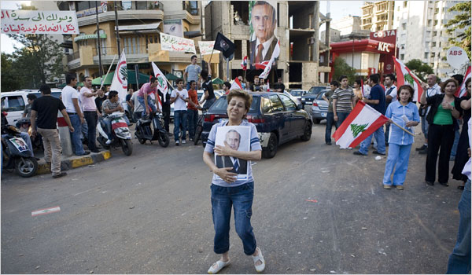
Bryan Denton for The New York Times
Celebrations erupted Sunday in several Beirut neighborhoods after lawmakers elected Gen. Michel Suleiman as president. The vote is to be followed by the creation of a new cabinet.
BEIRUT, Lebanon — After 18 months of grinding political conflict, Lebanon’s Parliament elected a new president on Sunday, in the first formal step toward enacting a new power-sharing pact among the country’s bitterly divided political factions.
Wild bursts of celebratory fireworks echoed across the capital as the deputies gathered to vote in Gen. Michel Suleiman as president, a post that had been unfilled since November. The vote is to be followed in the coming days by the creation of a new cabinet, according to the agreement reached last week.
Although that deal was a clear victory for the Shiite militant group Hezbollah and its allies in the opposition, many Lebanese across the political spectrum have greeted it with relief and even joy, preferring a compromise at almost any cost to the resumption of a conflict that crippled the government and brought Lebanon to the brink of civil war.
After taking the oath of office, President Suleiman, who had been the army chief, gave a brief speech in which he made deferential gestures toward both sides of Lebanon’s political divide. He expressed support for the international tribunal to investigate the murder of former Prime Minister Rafiq Hariri, a priority of the United States-backed government political alliance.
But he also spoke of the need for a defense strategy that would make use of the experience of the “resistance” in fighting Israel — a nod to Hezbollah.
The vote, shown live on all of Lebanon’s major TV stations, illustrated the international stakes involved in this small country’s fractious politics. Foreign ministers from some of the countries considered key players in Lebanon attended, including Iran, Syria and France.
Other world leaders sent their congratulations, including President Bush, who released a statement saying he hoped the new agreement would “usher in an era of political reconciliation to the benefit of all Lebanese.”
But the guests of honor appeared to be the emir and foreign minister of Qatar, who led the Arab delegation that brokered the agreement last week in the Qatari capital, Doha.
After President Suleiman spoke, the Qatari emir, Sheik Hamad bin Khalifa al-Thani, was allowed to give his own speech, a notable honor. In it, he surprised many observers by taking aim at an old principle of Lebanese politics: “No victor, no vanquished.” That adage is often invoked in an effort to limit the repercussions of the country’s many internal conflicts. But the Qatari emir said he hoped it would no longer apply, because it “seems to bury the crisis rather than resolve it.”
That question — whether the new agreement will help resolve the complex political and sectarian conflicts here, or simply bury them for a while — remains on the minds of many Lebanese. Although the Doha agreement allows for the creation of a new government, it does not address the questions that provoked the crisis 18 months ago.
“Is this just another brief respite?” said Samir Khalaf, a professor of sociology at the American University of Beirut. “I hope not. I hope we are witnessing the beginning of the Lebanon we have been hoping for, a Lebanon that will not be a battleground for unresolved regional conflicts.”
But the main note echoing around Beirut on Sunday was one of optimism, and spontaneous celebrations burst out in several neighborhoods. Young men danced in the streets and shot off fireworks.
In Verdun, an area west of the city, Maya Kambris, 26, had returned from her job as a banker in Dubai to watch the celebrations. “Electing Suleiman is not going to solve the problems,” she said. “But it’s a good thing. At least now we can try to solve the problems through constitutional means.”
Nada Bakri contributed reporting.
Copyright 2008 The New York Times Company

