'Dozens killed' in clashes in Libyan town of Sabha
By BBC
28 March 2012

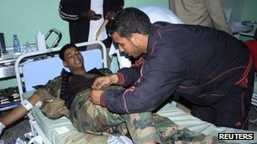
At least 70 people have reportedly been killed in fighting between militias around the Libyan town of Sabha.

Former rebels and ethnic Toubou gunmen began clashing after the killing of a militiaman on Sunday.

A ceasefire was agreed on Wednesday, but reports of fresh fighting emerged later in the day.

Hundreds of government troops have been sent to the region and mediation efforts are underway, according to government spokesman Nasser al-Manaa.

He said more than 70 people had been killed and more than 150 wounded since Monday.

Abdelmajid Seif al-Nasser, a local official who said he had quit his post on the ruling National Transitional Council (NTC) in protest at the violence, told AFP news agency: "There are still clashes [in Sabha] but not as intense.

"The national army and a committee of elders have entered the town in a bid to secure a truce."

The NTC is facing stern tests of its authority from local militias in different parts of the country.

The reported casualty figures suggest intense fighting with the forces of Libya's new government, but they are impossible to verify, reports the BBC's Kevin Connolly in Tripoli.

Some African tribes in southern Libya, such as the Toubou, feel they are not treated as equals by Arabs from the coastal cities of the north who tend to dominate the country's government and security forces, says our correspondent.

Other Libyans accuse the Toubou of involvement in the smuggling of illegal migrants trying to get to Europe through via Libyan ports, he adds

