ICC requests Libya hand over Saif al-Islam

By Al Jazeera
04 April 2012

International Criminal Court again urges Tripoli to surrender Muammar Gaddafi's son, wanted for crimes against humanity.

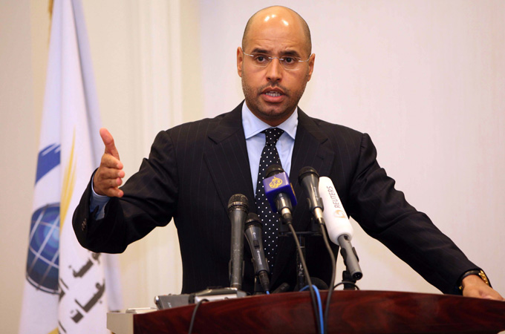
Libyan authorities want to put Saif al-Islam Gaddafi on trial in his home country [Reuters]

The International Criminal Court (ICC) has again asked Libyan authorities to surrender former Libyan leader Muammar Gaddafi's son, Saif al-Islam, who is wanted for crimes against humanity by the permanent tribunal.

Saif al-Islam was arrested in November in Libya's remote southern desert, and has been held largely without access to the outside world since then.

Libyan authorities say they plan to put him on trial, and - despite requests from The Hague - have so far taken no action to hand him over.

In a written ruling published on Wednesday, judges at the court rejected a request by Libya to postpone handing over Saif and urged the country's rulers to "proceed immediately with the surrender".

"The Chamber [of the ICC] recalls Libya's obligation to surrender Gaddafi to the Court as of the day the warrant of arrest against Gaddafi was notified to the Libyan authorities," the ICC ruling said.

"The Chamber further notes that, despite the Chamber's request in its 7 March 2012 Decision, the Government of Libya has not informed the Chamber hitherto of its decision to grant the Surrender Request.

"Absent any justification for postponing the execution of the Surrender Request, the Government of Libya must therefore make its decision to grant the Surrender Request and afford Gaddafi the procedure described in article 59 of the Statute which necessarily follows from arresting a person pursuant to a surrender request.

"The Chamber wishes to clarify for all possible purposes that any failure on the part of the Government of Libya to comply with its obligations to enforce the warrant of arrest against Gaddafi may warrant that the Court make a finding to this effect."

Saif's father also was indicted by the court, but was killed in October.

Source: Al Jazeera and agencies

