International condemnation grows against Malian coup

By The Telegraph

23 March 2012
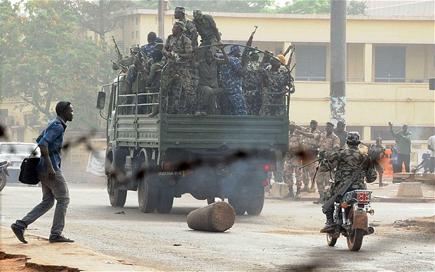
Credit: AFP/GETTY
Soldiers make their mark in Bamoko, the capital of Mali.

The soldiers - who call themselves the National Committee for the Establishment of Democracy - said they had acted because of the government's "inability" to put down a Tuareg-led insurrection in the north.
President Amadou Toumani Toure was initially holed up in the presidential palace as shots were traded outside, but managed to flee the premises.
A military source said he had since moved to a military camp with loyal members of an elite paratrooper unit.
As sporadic gunfire rang out in the capital Thursday, Western powers and the African Union condemned the mutiny, Mali's first coup in 21 years.
A statement from the UN Security Council said its members "strongly condemn the forcible seizure of power from the democratically elected government of Mali by some elements of the Malian armed forces."
The 15-nation body called on the rebels "to ensure the safety and security of President Amadou Toumani Toure and to return to their barracks."
France suspended cooperation with its former colony, also calling on the mutinous soldiers not to harm Toure.
And Washington, which has repeatedly voiced fears that parts of Mali and neighbouring countries are becoming a safe haven for jihadi extremists, called "for the immediate restoration of constitutional rule."
Junta spokesman Lieutenant Amadou Konare said the takeover was because of a "lack of adequate (military) material to defend the nation".
Claiming to speak for the army, he said the junta "solemnly commits to restore power to a democratically elected president as soon as national unity and territorial integrity are re-established."
The man presented as their leader, Captain Amadou Sanogo, declared a national curfew as the rebels announced all borders had been closed until further notice.
Konare appeared on public television late Thursday and said the curfew would be in place from 1800 GMT to 0600 GMT.
The coup leaders also ordered all civil servants back to work from next Tuesday.
Renegade soldiers in the northeastern city of Gao detained their military chiefs in support of the coup.
In Bamako, military men were seen stealing private cars and looting.
But it remained unclear how tight the new junta's grip on power was.
"The president is in Bamako, he is not at an embassy. He is in a military camp where he is in command," a military source said on condition of anonymity.
The elite "Red Beret" paratroopers were keeping watch, he added.
The president is himself a former paratrooper who led the ouster of "president-for-life" Moussa Traore in 1991 before handing power to civilians. He won an election in 2002 and was re-elected in 2007.
Military sources spoke of one rebel soldier having been killed in the fighting. Mali's Red Cross reported about 40 injured, including three to four civilians caught in the crossfire in Bamako and Kati.
A statement from Amnesty International denouncing the coup said at least three people had been shot dead, with 28 wounded.
Journalists said soldiers had ransacked offices at the headquarters of Mali's public radio and television stations, stealing cameras and computers and smashing down doors.
A few dozen soldiers appeared on television after hours of music videos had played in a loop. They appeared to be largely rank-and-file green-beret soldiers, with only two officers present.
Mali is usually seen as politically stable, but unrest in the north, where Tuareg tribes have long felt ignored by a southern government and where Al-Qaeda has also taken root, has created a major security problem.
The demise of Libya's Moamer Kadhafi compounded the situation: hundreds of battle-hardened heavily armed Tuareg who had fought for him returned to Mali, ready to take up a decades-long struggle for independence.
Under Toure's leadership, Mali - which has battled successive Tuareg rebellions since independence and more recently Al-Qaeda in the Islamic Maghreb - has been hailed as a growing democratic success.
But in mid-January the Tuareg launched a fresh rebellion for the independence of what they call Azawad, which makes up the vast desert northern triangle of the bow-tie shaped nation.
The fighting has forced as many as 206,000 people to flee their homes, compounding a humanitarian disaster at a time of drought and food shortages, a UN agency said Thursday.
Western powers - concerned that the north could become a safe haven for Al-Qaeda - were quick to call for order to be restored.
UN Secretary General Ban Ki-moon voiced "deep concern", as did neighbouring Algeria, Bamako's main partner in the fight against Al-Qaeda. Morocco, Nigeria and South Africa also condemned the coup.
The World Bank and the African Development Bank announced they were suspending development aid to Mali.
They joined the African Union and the West Africa regional bloc ECOWAS in condemning the coup and called for a swift resolution to the crisis.
Copyright 2012 The Telegraph Media Group Ltd.

