Mali Coup Leaders Face Sanctions and Concern Over Timbuktu

By Lydia Polgreen, The New York Times

3 April 2012
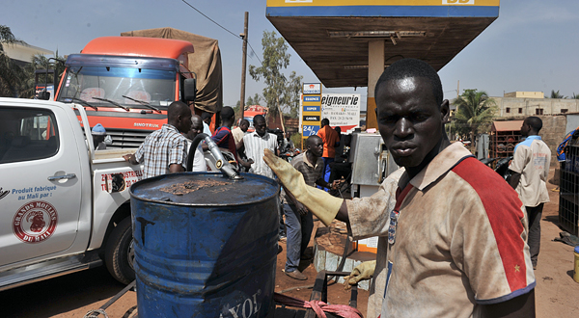
Credit: Issouf Sanogo/Agence France-Presse — Getty Images
Residents lines up at a fuel station in Bamako, Mali, on Tuesday, as the country experienced shortages of fuel.

JOHANNESBURG — The military officers who overthrew the president of Mali suffered dual setbacks on Monday, as West Africa’s regional trade bloc imposed tough sanctions against them and separatist rebels secured the ancient desert crossroads of Timbuktu, virtually sealing their control over the northern half of the troubled nation.
Malian junta soldiers patrolled a road in Kati, outside Mali's capital Bamako, on Sunday.
The fall of Timbuktu, a backwater at the southern edge of the Sahara, was the latest in a series of steady advances by the rebels and another blow for a nation struggling to come to grips with a coup that deposed its elected president last month and replaced him with a junta of junior military officers.
The rebel takeover of the city reverberated far beyond Mali’s borders. On Tuesday, the Paris-based United Nations Educational, Scientific and Cultural Organization, or Unesco, which has designated Timbuktu a World Heritage Site, said it was concerned about the impact of the fighting there, urging the Malian authorities to fulfill the “obligation of countries to safeguard their heritage in times of war.”
In a statement, Irina Bokova, Unesco’s director general, referred specifically to “Timbuktu’s outstanding earthen architectural wonders that are the great mosques of Djingareyber, Sankore and Sidi Yahia,” calling them “essential to the preservation of the identity of the people of Mali and of our universal heritage.”
The locations were made a heritage site in 1988 and bear “witness to the golden age of Timbuktu in the 16th century and to a history that stretches even further back to the 5th century A.D.,” Ms. Bokova said.
The landlocked nation’s neighbors in West Africa meanwhile closed their borders to all nonhumanitarian trade with Mali and froze its accounts in the regional bank, the president of Ivory Coast, Alassane Ouattara, told reporters in Senegal at an emergency meeting of the regional bloc, known as the Economic Community of West African States. The group had threatened the coup leaders with the sanctions last week if they did not surrender power and restore democracy.
In the north, the fall of Timbuktu and other cities has greatly undercut the rationale of the coup leaders, who argued that they needed to overthrow President Amadou Toumani Touré because he had failed to properly arm and equip them in their fight against the rebels. In the days since the coup, the rebels have made their most significant gains, seizing towns like Gao and Kidal.
On Sunday, trucks carrying fighters from the National Movement for the Liberation of Azawad, the main rebel group of Tuareg tribesmen, paraded into Timbuktu, residents and local officials said. The Associated Press reported that a smaller rebel group, Ansar ud-Din, was also in the city. Residents reported seeing its black flag flying, and said fighters from the group, which espouses an Islamist philosophy, were on the streets to prevent looting.
“It is very unclear which movement has control where,” said Baz Lecocq, a professor of African history at Ghent University in Belgium who has written widely on the Tuaregs. While the main group of separatist Tuaregs is secular, he said, Ansar ud-Din seeks to impose a version of Sharia law.
The two groups have attacked together in their unprecedented push across northern Mali, Dr. Lecocq said, but do not have formal ties and could find themselves at odds over the future course of the region, especially on religious issues.
“Things develop in very unexpected ways these days,” he said. “We don’t know who has the upper hand.”
Moreover, he said, fighting may soon give way to famine as the cumulative effects of armed battles, a lack of centralized authority and a severe drought impose a harsh season of heat and suffering in coming months.
Fida Ag Mohammed, a Tuareg elder who tends a library of crumbling ancient manuscripts near Timbuktu, said the rebellion had rattled the ancient city.
“They have taken the whole of the north,” Mr. Mohammed said in a telephone interview. He said that the price of food had risen, and that people in Timbuktu were worried about what the rapidly evolving events in Mali would mean for them. Asked if the city’s Tuaregs supported the rebellion, he replied: “The people support whoever is in power. What else can they do?”
The rebel gains in the north have been swift, seeming to capitalize on the chaos of the coup. The Tuaregs are a nomadic people who live largely in the Sahara, spanning Niger, Mali, Algeria and Libya. For centuries they plied caravan routes across the desert, but colonial borders turned them into citizens of several nations. In the 1960s and 1990s, Tuareg rebellions erupted in the Sahara, seeking autonomy or independence. Violence flared again in 2007 in Niger, where Tuareg rebels seeking to wrest control of the country’s rich uranium deposits mounted a rebellion.
Col. Muammar el-Qaddafi, Libya’s former leader, supported Tuareg rebellions in Mali and Niger over several decades, and analysts in the region say the current uprising is closely linked to the fall of Colonel Qaddafi, whose weapons are suspected of playing a major role in the Malian rebels’ success.
Alan Cowell contributed reporting from London and J. David Goodman from New York.
Copyright 2012 The New York Times

