ICC to consider allegations of atrocities in Mali

By BBC News

24 April 2012
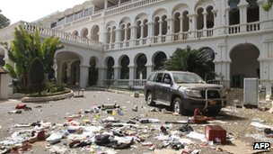
Credit: AFP
The presidential palace in Bamako was looted during the coup

The International Criminal Court has warned it may investigate allegations of atrocities committed in Mali since violence erupted there in January.
Prosecutors are assessing reports of killings, rapes and of conscripting child soldiers in the country.
Rebel soldiers ousted President Amadou Toumani Toure in March in a move condemned by the UN.
Coup leaders said they had not been given enough arms to tackle a rebellion by ethnic Tuareg in the north of Mali.
Mali's Tuareg rebels are now in control of the north of the country - one of the poorest in the world.
The ICC said they would consider claims from several sources, including senior UN officials, before deciding whether or not to to open a war crimes investigation.
The country has now returned to civilian rule - with the country's parliamentary speaker, Dioncounda Traore, sworn in as interim president on 12 April.
Copyright 2012 BBC News

