May 7, 2008

A Challenge Getting Relief to Myanmar’s Remote Areas
By THOMAS FULLER
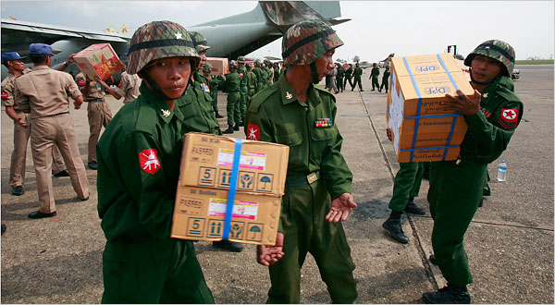
Vorasit Satienlerk/Reuters
Burmese soldiers unloaded boxes from a Thai military plane containing medicine and food supplies for cyclone victims in Yangon on Tuesday.
BANGKOK — International aid agencies began distributing food in Myanmar’s commercial capital and main city, Yangon, on Tuesday but there was uncertainty that the assistance would reach people stranded without shelter in the remoter reaches of the country’s vast Irrawaddy Delta.
Bad roads, a lack of cooperation from the country’s military government and a breakdown in telecommunications are factors that could hamper relief efforts as aid agencies begin to assess the damage to the densely populated delta, which appears to have borne the brunt of Saturday’s cyclone.
Even before the storm hit, many towns and villages in the area were accessible only by boat or helicopter.
A growing list of countries have pledged aid and assistance but there appeared to be disagreement as to how to handle Myanmar’s authoritarian government, which may be suspicious of international interference.
“If it were a different situation we would be mobilizing some helicopters now,” said Tony Banbury, the regional director of the United Nations World Food Program. “We recognize that the government may not want international helicopters flying in their country for better or worse.”
Two of Myanmar’s neighbors sent supplies immediately: Thailand on Tuesday dispatched a transport plane loaded with food and medicine to Yangon and India sent two naval ships loaded with food, tents, blankets, clothing and medicines.
The United States announced it might send $250,000 worth of aid, but said the shipment was conditional on an American disaster response team being allowed into the country as well.
In making the announcement Monday in Washington, the first lady, Laura Bush, said she was concerned that Myanmar would not accept the aid. She also called the military government “very inept.”
Canada, China, the European Union and Japan all pledged aid without conditions.
Australia’s foreign minister, Stephen Smith, said his government was “ready, willing and able” to offer humanitarian assistance and withheld judgment on the military government’s handling of the aftermath of the cyclone, saying the priority for his country was “rendering assistance to thousands of displaced people.”
“I just don’t think we’re in a position to make that sort of judgment now given the difficulties of communication,” Mr. Smith said in comments reported by The Associated Press.
Mr. Banbury of the World Food Program said he feared that the assistance pledged to Myanmar was “ad-hoc and uncoordinated.”
“It’s great that others are sending some kinds of relief supplies but it will be a challenge to distribute them,” he said.
Saturday’s cyclone felled trees and destroyed dwellings in Yangon. But the greatest damage was in the low-lying delta. The delta is former swampland that was converted during British colonial times into one of the world’s largest rice-growing areas. It is exceptionally fertile but difficult to traverse.
“The infrastructure was degraded to begin with,” said Sean Turnell, an expert on Myanmar at Macquarie University in Sydney, Australia. Dykes had collapsed, irrigation systems failed and bridges were sometimes impassable before the cyclone, Mr. Turnell said.
The delta was only sparsely inhabited until the 1900s but by the early 20th century had been transformed into what became known as the rice bowl of Asia. Rice grown in the delta fed large swaths of the British empire and colonial Burma, the former name for Myanmar, was for several decades the world’s largest rice exporter. But under military rule, Myanmar has seen a steep decline in rice production as rice paddies have been neglected, international sanctions have prevented many buyers from handling Myanmar’s rice and a lack of investment in modern port facilities and port dredging has made it very expensive to ship rice in or out of Myanmar.
The felling of mangrove swamps and the destruction of dense primary jungle removed natural barriers and may have left populations more vulnerable.
“Obviously nobody thought of the environmental consequences of all this,” Michael Adas, a professor of history at Rutgers University and the author of The Burma Delta, a book about the transformation to a rice-growing center.
Among the most vulnerable people are those who have moved onto the islands and peninsulas jutting out into the Andaman Sea.
“They build their lives around water,” said Aung Din, a Burmese dissident living in the United States who has family in the delta. “Now water is flooding them.”
Aung Din said an ineffectual response to the cyclone would likely to further resentment against Myanmar’s military government.
Farmers are already frustrated that they must buy fertilizer from businesses controlled by companies linked to the junta, Aung Din said. The military also forces them to sell rice at below market prices and bans farmers from selling their crops in other regions of the country.
The country had been expected to export about 100,000 tons of rice this year, a small quantity compared to international trade of nearly 30 million tons, and minuscule compared to global consumption of more than 410 million tons. Ben Savage, the managing director for rice at Jackson Son & Co. (London) Ltd., one of the world’s oldest rice brokerages, said the cyclone damage was not likely to have much effect on international prices.
The delta has a history of protest and restiveness. In colonial times, when as many as one million Indians came to work as laborers, financiers and traders, anti-Indian and anti-colonial riots periodically broke out.
Mr. Turnell of Macquarie University estimates the total population of the delta to be about 15 million to 20 million people.
But given the crumbling infrastructure and the large number of isolated villages, he says the full extent of the damage from the weekend’s cyclone may never emerge.
“We’ll never know how many died,” he said. “This a country that hasn’t had a full census since 1937.”
Keith Bradsher contributed reporting from Hong Kong.
Copyright 2008 The New York Times Company

