May 22, 2008

U.N. Chief Making Appeal to Myanmar
By SETH MYDANS

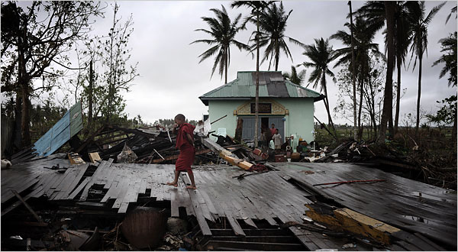
Lisandru/Agence France-Presse — Getty Images
A Buddhist monk walked amid the ruins of his monastery in Kaunt Chaung, an isolated area only accessible by boat, on Monday.
BANGKOK — The United Nations secretary general, Ban Ki-moon, stopped here Wednesday en route to Myanmar, where he hoped to pry open the door to more international aid at what he called a “critical moment” in the country’s slow recovery from the cyclone that left at least 100,000 people dead or missing.
“Aid in Myanmar should not be politicized,” he said in Bangkok on Wednesday. “Our focus now is on saving lives.”
But the opening offered by Myanmar appeared to be a narrow one and some analysts said the ruling generals were conceding only enough to defuse international pressure after the May 3 cyclone.
Suspicious of foreigners bearing relief supplies, the government has so far barred any major flow of aid from the United Nations and Western donors.
On Wednesday it said it would not allow delivery of aid from U.S. naval vessels waiting offshore.
Ban was to fly on Thursday to Myanmar where he said he hoped to meet the leader of the military junta, Senior General Than Shwe, who has so far not responded to his messages or taken his telephone calls.
He was also scheduled to attend a meeting on Sunday of international donors in Yangon, at which he said he hoped to help coordinate aid, along with Myanmar’s neighbors in the 10-member Association of Southeast Asian Nations, or Asean.
His visit followed an agreement this week by Myanmar to let Asean to coordinate a relief program and send in medical workers.
That opening falls far short of the huge relief operation that the United Nations says is needed to help an estimated 2.5 million victims who face shortages of food and water and a growing threat of disease.
The official government newspaper, The New Light of Myanmar, said Wednesday the country would not accept relief supplies carried by the U.S. ships that are waiting, along with French and British vessels, outside its territorial waters.
“The strings attached to the relief supplies carried by warships and military helicopters are not acceptable to the Myanmarese people,” it said. “We can manage by ourselves. Myanmar has many good neighborly countries.”
The United States has insisted that it has no ulterior motive in offering disaster relief and has promised to withdraw its helicopters and personnel after deliveries have been made.
“They are really fearful that the United States is involved in regime change as it has said from 1990 on,” said David Steinberg, an expert on Myanmar at George Washington University in Washington, D.C, speaking of the junta. “As a member of Asean, they feel they can control the situation.”
He said the motives and methods of the junta have not changed over the years. When it is under pressure, the junta offers promises and calibrated concessions, but holds its ground.
“The overwhelming motive is to keep power,” Mr. Steinberg said, “and in order to do that you take off bits and pieces of pressure as you see the need. But you don’t help people if you are going to jeopardize your superior role.”
A Burmese exile magazine, The Irrawaddy, which is based in Thailand, took the analysis a step further Tuesday, saying, “The Burmese junta is still in the driver’s seat. Asean, the U.N. and the rest of the world are — again — being manipulated by the oppressive generals.”
In Washington, the United States ambassador to Asean, Scot Marciel, told a Congressional hearing Tuesday that “the door must be opened far wider and rapidly to prevent a second catastrophe” of further death.
Myanmar has set the death toll in Cyclone Nargis at about 78,000, with nearly 56,000 people missing, but the United Nations and relief donors believe at least 100,000 people died.
“Without an adequate and independent assessment of the situation and current needs, as well as a commitment by the regime to provide the necessary access, a pledging conference is unlikely to produce the results we seek,” Mr. Marciel said.
Speaking in New York before his departure, Mr. Ban said that he hoped to set up a “logistics hub” in Myanmar or nearby, and that the United Nations and Asean could join in coordinating relief efforts.
He said the government had given permission for nine helicopters from the United Nations World Food Program to ferry aid to survivors, a significant softening of its blanket rejection of U.N. aid workers.
“Further similar moves will follow — including expediting the visas of relief workers seeking to enter the country,” Mr. Ban said. “I am confident that emergency relief efforts can be scaled up quickly.”
He said a major increase in aid was urgent. “This is a critical moment for Myanmar,” he said. “We have a functioning relief program in place but so far we have been able to reach only about 25 percent of Myanmar’s people in need.”
In its commentary rejecting U.S. aid, The New Light of Myanmar vented its concerns about foreign donors, saying they were a greater threat than the cyclone.
“Our country is going through a variety of storm-like plots and intrigues that are much severer than Nargis, and they are endless,” it said.
“They are none other than envy storms, criticism storms and rumor storms created by certain Western countries and national traitors at home and abroad who are showing negative attitudes toward our nation and our people.”
Copyright 2008 The New York Times Company

