May 23, 2008

U.N. Leader Sees Myanmar Cyclone Devastation
By SETH MYDANS
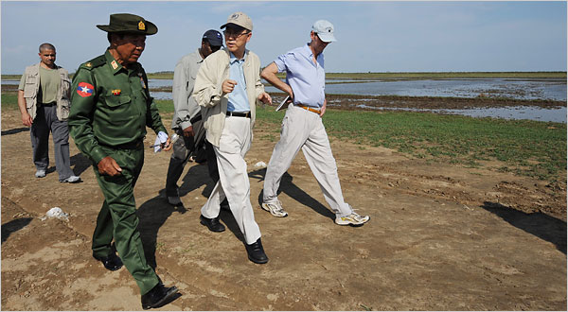
Pool photo by Stan Honda
The United Nations Secretary General, Ban Ki-moon, center, visited a camp for cyclone survivors on Thursday in Kyondah village, Myanmar.
BANGKOK — The United Nations Secretary General, Ban Ki-moon, had a first-hand look Thursday at some of the damage caused by Myanmar’s cyclone as a limited program of international aid gained momentum.
Removing his shoes and socks as a sign of respect at Myamar’s holiest temple and with the country’s prime minister standing nearby, Mr. Ban called on the government to coordinate with international donors “so that the flow of aid and aid workers’ activities can be carried out in a more systematic way.”
The United Nations says that the Myanmar authorities are still barring foreign relief workers from the hardest hit areas, in the Irrawaddy delta, and that nearly three weeks after the May 3 cyclone, only about 25 percent of those in need have received aid.
But relief agencies in Bangkok said that they were finally breaking through a logjam created by Myanmar’s suspicious and inefficient government and that a small but steady flow of aid had begun.
The first of 10 helicopters from the United Nations World Food Program arrived Thursday under an agreement in advance of Mr. Ban’s visit, said Marcus Prior, a spokesman for the agency.
Relief flights into Myanmar have increased to about 10 a day, officials said; a distribution system is taking shape; trucks and barges have been contracted to carry supplies into the delta, and international relief workers are mostly receiving visas, although they are still barred from traveling outside the main city, Yangon.
"We are scaling up, but less quickly than we would have done if we didn’t have the same red tape restrictions," said Richard Horsey, a spokesman for the United Nations.
Though the increase in relief flights was a step forward, he said, an unfettered operation would involve "something like one flight every half hour."
"We are still not where we need to be, given that 2.4 million people are in need, in the latest United Nations numbers, of which 1.4 million are in urgent need of assistance," he said. "These are fairly big numbers we are talking about."
Cyclone Nargis, which struck in the early hours of May 3, killed 78,000 people, with another 56,000 missing, according to official government figures. According to the United Nations, the number of deaths may have exceeded 100,000.
On the first day of his visit Thursday, Mr. Ban met with Prime Minster Thein Sein as well as with international aid agencies, and he was scheduled Friday to meet the leader of the military junta, Senior General Than Shwe, according to officials traveling with him.
His itinerary did not include a meeting with the pro-democracy leader, Aung San Suu Kyi, who has been under house arrest for 12 of the last 18 years. Mr. Ban has emphasized the non-political nature of this visit and it appeared that he would be the first United Nations official in many years not to request a meeting with her.
Since the early 1990’s, the United Nations has sent a series of envoys to Myanmar to address the junta’s record of political and human rights abuses. One result has been a strained relationship between the generals and the United Nations.
On Sunday Mr. Ban was scheduled to attend a multinational donors’ conference in Yangon, to be coordinated by both the United Nations and the 10-member Association of Southeast Asian Nations, which includes Myanmar.
Details of Mr. Ban’s visit were reported by international news agencies, which had been invited to travel with him. Myanmar has mostly been closed to foreign journalists although a small number have slipped into the country.
Myanmar’s foreign minister told Mr. Ban that the government had already completed the relief phase of the operation and was focusing now on reconstruction, according to a United Nations official who requested anonymity for reasons of protocol.
Critics of the junta have said this position is a ploy to extract reconstruction materials and machinery from donors although relief aid is still urgently needed.
The government has put the cost of the cyclone at $10 billion, although it is not clear how it arrived at this figure.
Brad Adams, Asia director for the group Human Rights Watch, said Mr. Ban should avoid the junta’s "time-tested trap of dangling petty concessions as a delaying tactic."
At the donors’ conference, Mr. Adams said, “The diplomats shouldn’t be talking about reconstruction when they still need to be talking getting access for emergency aid.”
Half a million people lost their homes in the cyclone, according to the International Federation of Red Cross and Red Crescent Societies.
Save the Children estimates that 30,000 children in the delta are suffering from severe acute malnutrition and will die by the first week of June unless they are rescued.
"With the fast-approaching monsoon season and the end of the planting season in 5 to 7 weeks, prompt action is necessary if further unnecessary suffering is to be avoided," the relief agency Oxfam said in a statement.
Copyright 2008 The New York Times Company

