Burmese junta frees 15 opposition activists
- Peter Walker
- Tuesday June 10 2008
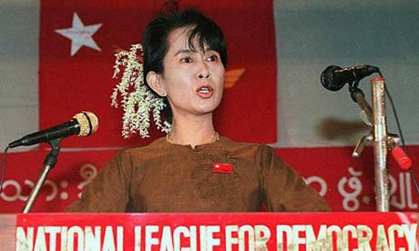
Aung San Suu Kyi. Photograph: David Van Der Veen/EPA
Authorities in Burma have freed 15 activists from Aung San Suu Kyi's opposition party two weeks after they were detained for publicly demanding her release from house arrest, the party said today.
The members of the National League for Democracy (NLD), which won a sweeping election victory in 1990 that was ignored by the ruling military junta, were taken away in police trucks on May 27 after marching from the party headquarters to Suu Kyi's house.
"All 15 party members were freed last night," an NLD spokesman, Nyan Win, said.
They had been held for two weeks inside a former government technical school on the outskirts of Burma's main city, Rangoon, which had previously been used to hold hundreds of Buddhist monks following pro-democracy protests in September that were violently put down by the military.
The NLD members' protest came on the day the junta was due to announce whether Suu Kyi would be released from house arrest or kept detained in her Rangoon home for a further period. Shortly after the activists were held, the government announced she was being detained for another 12 months.
The Nobel peace laureate has been under house arrest for more than 12 of the past 18 years, and for the past five years continuously.
Separately, the NLD said today it would launch a legal challenge against Suu Kyi's continued house arrest, the AFP news agency reported.
Suu Kyi is held under a 1975 law intended to guard against "destructive elements". According to legal experts, people cannot be held for more than five years under this statute.
The extension of Suu Kyi's house arrest came as the junta already faced fierce international criticism for refusing to accept large-scale international aid following Cyclone Nargis in early May, which killed more than 130,000 people. An estimated 2.4 million people remain in desperate need of food, shelter and medical care.
Last night in New York, the head of the UN humanitarian agency, John Holmes, defended its policy of trying to work with the junta to deliver aid, saying the other option – bringing in assistance by force – would not have worked.
As Burma's government stalled repeatedly on allowing aid into the country, France suggested invoking the "responsibility to protect", enshrined in a 2005 UN resolution, to deliver aid without waiting for official approval, for example by air drops.
Cyclone Nargis, which killed at least 134,000 people after striking in the first days of May, sparked widespread condemnation of the ruling generals for initially blocking international aid workers from entering the country.
"I've never seen a realistic alternative to the approach we've pursued spelled out by anybody," Holmes said.
"Nor have I met anyone engaged in the operation on the ground who thought that there was an alternative which could actually have helped those most in need."

-This article was first published on guardian.co.uk on Tuesday June 10 2008. It was last updated at 10:26 on June 10 2008.

© 2008 Guardian News and Media Limited

