Burma: Lawyers, Students & Alumni Defending Earth Rights
February 2010

Recent activities and ongoing programs:
+ Congratulations to our 2009 EarthRights School Mekong Graduates!
+ Alumni Publication: "I Want to Eat Fish. I Cannot Eat Electricity."
+ The Mekong Legal Advocacy Institute (MLAI) Strides Forward
+ ERI's Response to Total: "Total Impact 2.0"
+ Taking on Chevron on International Human Rights Day

Congratulations to our 2009 EarthRights School Mekong Graduates
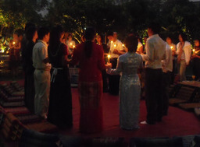
An EarthRights School Mekong (ERSM) graduation ceremony was held in Chiang Mai, Thailand, on December 18, 2009 to celebrate our 2009 students' successful completion of the ERSM program and conclude the school's fourth year. ERI staff, students from the EarthRights School Burma (ERSB), friends, and representatives from a number of partner organizations gathered together at the school to reflect on another successful year. The festivities opened with a candlelight ceremony in which ERSM students, alumni, and staff shared their thoughts and reflected on the past year together. A student representative from Tibet delivered a speech on behalf of the ERSM students, and students sang both traditional and modern songs to celebrate their successful graduation from the EarthRights School Mekong.
The deadline for applications for the 2010 program is March 10th.

Alumni Publication: I Want to Eat Fish. I Cannot Eat Electricity.
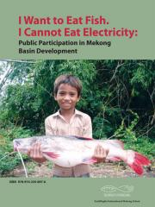
Over the past year, the Mekong Alumni program compiled a book of EarthRights School Mekong student and alumni field reports with the goals of (1) increasing awareness of the adverse impacts of large-scale development projects in the Mekong region, and (2) proposing alternative models of development incorporating improved transparency mechanisms and public participation in decision-making processes. The target audiences are NGO workers, academics, government officials, and the general public in the six Mekong countries. The book, I Want to Eat Fish. I Cannot Eat Electricity: Public Participation in Mekong Basin Development, was released to coincide with our 2009 graduation ceremony, and features articles by three years of Mekong School graduates from six Mekong countries.

The Mekong Legal Advocacy Institute (MLAI) Strides Forward
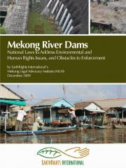
In January, the second session of ERI's Mekong Legal Advocacy Institute (MLAI) took place in Chiang Mai, Thailand, bringing together experts in international human rights law, international financial institutions, and other relevant public interest law topics, to collaborate with MLAI lawyers from the Mekong region. Presenters included renowned human rights lawyer Judith Chomsky, World Bank Inspection Panel expert Dana Clark, land use and resettlement specialist Natalie Bugalski. These presenters and others are working with our returning Mekong lawyers to share skills and build alliances to advance the critical public interest work of the MLAI participants.
The first MLAI session was held in September 2009. Between sessions, our growing network of Mekong lawyers collaborated with Samreth Law Group on the submission of an in-depth legal analysis to the Mekong River Commission (MRC) regarding proposals to build up to 11 dams on the lower mainstream of the Mekong River.

ERI's Response to Total: "Total Impact 2.0"
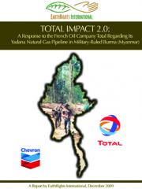
On September 10, 2009 EarthRights International (ERI) released two publications linking the oil giants Total S.A., Chevron Corporation, the Petroleum Authority of Thailand Exploration and Production Company Ltd. (PTTEP), and the Myanma Oil and Gas Enterprise (MOGE) to forced labor, killings, high-level corruption, and authoritarianism in connection to their Yadana natural gas pipeline in military-ruled Burma. The reports also document the flawed corporate social responsibility programs implemented by Total, the operator of the project, and reveal for the first time that the pipeline in Burma has generated more than US$7 billion dollars for the companies and the ruling State Peace and Development Council (SPDC).
On October 15, 2009 Total publicly released a 12-page response to ERI, and in December ERI responded with Total Impact 2.0, a detailed and fact-based rejoinder which finds that, while the company may be softening to criticism and to the idea of engagement with a nongovernmental organization (NGO) such as ERI, it has yet again misled the general public, investors, and policymakers regarding the impacts of their pipeline project in Burma. This report finds that the companies are still linked to violent abuses such as forced labor and killings in their project area, and that their project continues to generate multi-billion dollar revenues for the Burmese military regime.
In January, ERI released French and Burmese translations of the Executive Summary and Recommendations from the original reports, Getting It Wrong and Total Impact. "These new translations allow local voices to be heard by a critical wider audience, both inside Burma and in France, where Total is based" said ERI's Matthew Smith. ERI's reports are part of a broader effort to promote and protect the human rights of communities affected by resource extractive projects in Burma by amplifying local voices, exposing the actual impact of these destructive projects, and increasing corporate accountability, environmental protection, and revenue transparency in Burma's extractive industries." ERI would like to thank the International Federation for Human Rights (FIDH) for their generous support in the French translations.

Corporations and Human Rights Abuses: Taking on Chevron
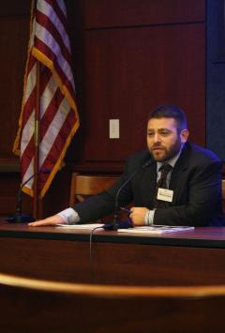
On December 10, International Human Rights Day, ERI co-hosted a panel discussion in the U.S. Capitol on Corporate human rights abuses and Chevron Corporation. The panel discussed a powerful new international campaign focusing on Chevron's human rights and environmental practices and impacts around the globe. Among the panelists was ERI's Campaigns Director, Paul Donowitz, who discussed Chevron's human rights and financial impacts in Burma, as well as the importance of transparency and accountability in the extractive industry. Mr. Donowitz's comments are available online.

EarthRights International (ERI) combines the
power of law and the power of people
in defense of human rights and the environment.
Learn more about our work at
www.earthrights.org

