Christians killed in Pakistan riots
Al-Jazeera
August 2, 2009
A child and four women are among at least eight Christians killed after 40 houses and a church were set ablaze amid riots with Muslims in eastern Pakistan, officials have said.
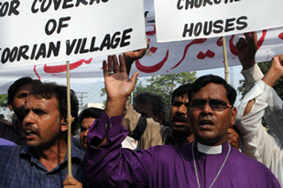
Police said the unrest between Muslims and Christians first flared late last month [AFP]

Dozens of people were also injured in the violence in Pakistan's Gojra village, which erupted after allegations surfaced that a Quran had been defiled, the officials said on Saturday.
"Six Christians including a child were killed and more than a dozen were injured in this sad incident," Shahbaz Bhatti, a federal minister of minorities, told the AFP news agency by telephone.
"Some people blamed the Christians for the desecration of the holy Quran," he said adding that the accusations were "baseless".
Mohammad Saleem, a correspondent for The Dawn newspaper in Pakistan, told Al Jazeera: "The clashes erupted when a boy of a Christian community allegedly desecrated a few pages of the holy Quran.
"The Christians said the Muslims were in a mood to attack the locality."
Renewed tensions
Police said that unrest between the two groups of villagers first flared late last month over a dispute over the Muslim holy book, which was later resolved.
But tensions erupted on Saturday when the Christian group were attacked again and their houses set on fire.
"Today, according to our information ... this is the same issue of alleged desecration of the Quran," Inkisar Khan, the city police chief, told reporters.
"All the dead are Christians. I was told that they were burned alive."
Television footage from the area showed police using tear gas to disperse an angry mob.
Desecrating the Quran is punishable by death under the blasphemy laws of mainly Muslim Pakistan, but no such sentences have been carried out.
Christians, who make up less than three per cent of Pakistan's population of 150 million, say the blasphemy laws are used as an excuse to victimise them.
Source: | Al Jazeera and agencies

