Hate Engulfs Christians in Pakistan
By SABRINA TAVERNISE, The New York Times
August 3, 2009

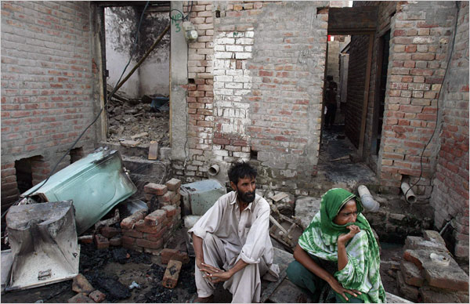 Mohsin Raza/Reuters- A Christian couple sat outside their destroyed home in Gojra on Sunday, a day after more than 100 Christian houses were burned and looted by a large mob.

GOJRA, Pakistan — The blistered black walls of the Hameed family’s bedroom tell of an unspeakable crime. Seven family members died here on Saturday, six of them burned to death by a mob that had broken into their house and shot the grandfather dead, just because they were Christian.

The family had huddled in the bedroom, talking in whispers with their backs pressed against the door, as the mob taunted them.

“They said, ‘If you come out, we’ll kill you,’ ” said Ikhlaq Hameed, 22, who escaped. Among the dead were two children, Musa, 6, and Umaya, 13.

The attack in this shabby town in central Pakistan — the culmination of several days of rioting over a claim that a Koran had been defiled — shows how precarious life is for the tiny Christian minority in Pakistan.

More than 100 Christian houses were burned and looted on Saturday in a rampage that lasted about eight hours by a crowd the authorities estimate was as large as 20,000 strong. In addition to the seven members of the Hameed family who were killed, about 20 people were wounded.

The authorities, who said the Koran accusation was spurious, filed criminal charges in the case late Sunday and apprehended at least 12 people. Officials said a banned Sunni militant group, Sipah-e-Sohaba, was among those responsible for the attacks, the third convulsion of anti-Christian mob violence in the region in the past four weeks.

Christians, who make up less than 5 percent of the entire population, are often treated as second-class citizens in Pakistan, where Islam is the official religion. Non-Muslims are constitutionally barred from becoming president or prime minister.

While some Christians rise to become government officials or run businesses, the poorest work the country’s worst jobs, as toilet cleaners and street sweepers.

It was the poorest class who lived in Christian Colony, a small enclave of bare brick houses where the mob struck Saturday. Its residents work as day laborers and peddlers in the market, often earning far less than the minimum wage, $75 a month.

The Hameeds were having breakfast when the mob descended, wielding guns, hurling stones and shouting insults (“Dogs!” “American agents!”) through their window. The Hameeds did not appear to have been singled out but had the misfortune of living where the mob entered the neighborhood and happened to be home at the time.

When the grandfather, Hameed Pannun Khan, 75, a house painter, opened the door to see what was happening, he was shot in the temple and crumpled to the ground. The crowd then pushed inside, and the rest of the family — at least 10 people — fled to the back bedroom and locked themselves inside. They listened from behind the door as the mob looted the house, dragging away a refrigerator and a cupboard.

Then came the smoke, thick white plumes under the door.

“Everyone was shouting to escape,” said Umer Hameed, 18. “There was no oxygen.”

They waited as long as they could, until they thought it was safe, and then made a run for it, but not everybody made it. Three women, the two children and a man were trapped when the roof collapsed in flames.

As he ran, Ikhlaq Hameed glanced back and saw his aunt. “She tried to come out, but the fire caught her,” he said. “The fire was on her face.”

The rampage began Thursday in a nearby village when Christians at a wedding party were accused of burning a Koran. Few here believed that, and state and federal officials who looked into the case said it was false. Still, local mullahs seized on the news, filing a blasphemy case against the Christian family.
“We were afraid because the clerics had been railing against us in the mosques,” said Riaz Masih, a Christian and retired math teacher whose house was gutted. “They said, ‘Let’s teach them a lesson.’ ”

Pakistan’s blasphemy law has been criticized as too broad, and many legal experts say it has been badly misused since its introduction in the 1980s by the military dictator Gen. Muhammad Zia ul-Haq. Anyone can file a charge, which is then often used to stir hatred and to justify sectarian violence.

“The blasphemy law is being used to terrorize minorities in Pakistan,” said Shahbaz Bhatti, Pakistan’s minister of minority affairs, in an interview in Gojra on Sunday.

The attackers here left a singed trail of destruction in their wake. The Hameeds’ house was a charred shell, its central room a heap of twisted fans, bicycles, children’s toys and a collapsed cage that had kept pet parrots. The kitchen was empty except for a teapot and a half-burned English dictionary open to the word “immoral.”

Their neighbor, a grain seller, Iqbal Masih (whose surname means “a follower of Jesus”), stood looking dazed, his dried corn spilled on the heap of twisted metal wheels that had been his sales cart. A chest for his daughter’s dowry had been destroyed.

Typical of such attacks, the police, overwhelmed by the mob, did little to stand in its way.

Christians here protested all day on Sunday, blocking the roads and refusing to bury the Hameeds until the authorities filed a criminal case. Late Sunday the authorities did, and the bodies were buried. That was little comfort to the Hameeds.

“Everything is gone now,” said Ikhlaq, his hand and arm blistered. “Our family. Our house. We don’t want to live here anymore.”

Waqar Gillani contributed reporting.

