Pakistanis shot at Somali mosque
BBC News
13 August 2009
At least five Pakistanis have been killed in a dawn attack at a mosque on the border of Somalia's semi-autonomous Puntland region, witnesses say.
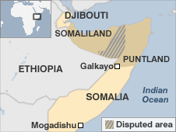
Armed men in masks entered a mosque in Galkayo and ordered six Pakistanis and one Somali outside, they said.
The gunmen then opened fire, killing five men and seriously injuring two.
Those targeted are said to be Muslim preachers. Puntland has been tense recently, but the reason for the latest attack is unclear.
The Pakistanis are thought to be missionaries from an Islamic branch called Tabliq who arrived in Galkayo on Tuesday.
Warning
Correspondents say it is common for groups of foreign preachers to spend several months travelling in Somalia on missionary work.
Tabliq is known for its peaceful ministrations and is popular in the war-torn Horn of Africa nation.
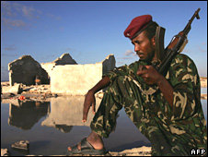
Puntland has been tense since the recent assassination of a minister
Somali commentators say its clerics do not talk about politics or law - and strive to avoid controversy.
Six religious leaders from the group were killed in the Somali capital, Mogadishu, in 2008, during fighting between Ethiopian troops supporting the government and Islamist militants.
In Galkayo, which lies on the boundary of Puntland and south central Somalia, security forces cordoned off the area after the shooting and were conducting house-to-house searches.
The country has been without an effective central government since 1991 and has recently been riven by fighting between Islamist insurgents and government troops.
The security situation in Puntland has been tense after the recent killing of an information minister.
Pirates operating off the Somali coast are based in the northern region, but it has seen less violence than the rest of the country.
However, a report from International Crisis Group released on Wednesday warned that if the government did not enact reforms, the region could break up violently.
It said friction within the Harti clan had undermined formerly consensual politics in Puntland, meaning that grievances including poverty, poor governance and corruption had not been tackled.

