Pakistan Sunni leader shot dead
Al Jazeera
17 August 2009
The leader of a banned Sunni armed group in Pakistan has been shot dead during an attack in the country's south.
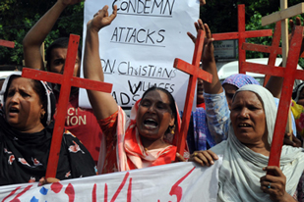
Sipah-e-Sahaba has been implicated in attacks on Christians as well as on Shia Muslims [AFP]

Allamma Ali Sher Haideri was killed on Monday along with one of his associates in a shooting at Pir Jo Goth village in Pakistan's Sindh province, police and Pakistani media said.
Pir Muhammed Shah, a senior Pakistani police official, said the attacker was also killed when Haideri's guards returned fire.
Several other of Haideri's men were also wounded in the incident.
Police were deployed across the district and the situation was tense in the area following the killings.
Haideri led the Sipah-e-Sahaba Pakistan, a Sunni group blamed for a string of sectarian attacks across Pakistan against minority Shias.
The group was also implicated in recent attacks on Christians in the city of Gorja, in which at least eight people died.
Shah said he suspected a personal grudge as the motive in the killing and said that the attacker had been identified.
Shias account for about 20 per cent of Pakistan's mostly Sunni Muslim population of 160 million.
More than 4,000 people have died in outbreaks of sectarian violence since the late 1980s.
Source: | Agencies

