Pakistan minister wounded in attack
Al Jazeera
2 September 2009

Armed men in Pakistan have opened fire on a vehicle carrying Pakistan's religious affairs minister, wounding him and killing his driver, police say.
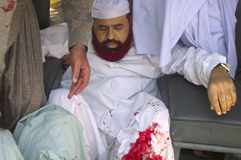
Hamid Saeed Kazmi survived the attack, but
was injured in the leg [Reuters]

The attack on Hamid Saeed Kazmi took place on Wednesday, close to his office in the Islamabad, the Pakistani capital.
Kamal Hyder, Al Jazeera's Pakistan correspondent, said: "The attacker, who is said to have been armed with an assault rifle, peppered the car with bullets ... after that the gunman was able to make good an escape, [while] the car lost control and went into a tree."
Muntizar Hassan, a police officer, said that Kazmi had survived the attack but that his driver had been killed.
Kazmi was said to have been shot in the leg. A bodyguard was also wounded in the attack.
Television pictures showed several bullet holes in the vehicle.
Kazmi, who belongs to the Barelvi sect of Sufi Islam, has been a vocal critical of the Taliban in Pakistan.
The Pakistani army launched a campaign in April to clear Taliban fighters from Swat and Buner, two valleys a few hours drive from Islamabad.
Pakistan's major religious parties quickly moved to condemn the attack on Kazmi.
Source: | Al Jazeera and agencies

