In Tribal Pakistan, Religious Parties Are Foundering
February 14, 2008
By CARLOTTA GALL
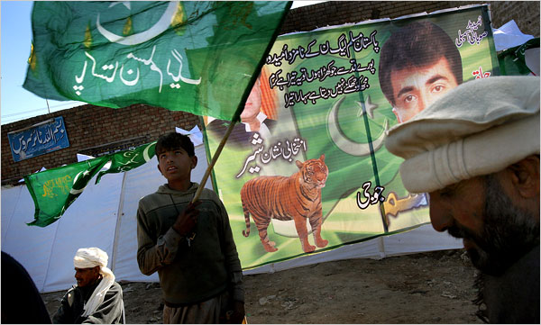
David Guttenfelder/Associated Press
Supporters of Nawaz Sharif, a former prime minister, on Wednesday in Chakwal, Pakistan. Parliamentary elections are Monday.
PESHAWAR, Pakistan — Senator Asfandyar Wali, the leader of an opposition party, the Awami National Party, is campaigning for the elections next week from the safety of his bed, under a quilt and propped up on bolsters for his bad back at his country home outside Peshawar.
Ill health aside, Mr. Wali is staying home because suicide bombers are seeking to kill him, his party has been warned by high-level government officials. There have been two bomb attacks on his party’s election gatherings in the last week. Two candidates have been killed, one in a suicide bombing and one in a shooting in Karachi.
Yet despite the attacks and the limited campaigning, his party is expected to do well in the parliamentary elections on Monday. The religious parties that for the last five years have governed the North-West Frontier Province and Baluchistan Province, which border Afghanistan and the tribal areas, are foundering.
Since being swept to power in 2002 on a wave of anti-Americanism and sympathy for the Taliban after the American invasion of Afghanistan, the mullahs here have found that the public mood has shifted against them.
People complain that they have failed to deliver on their promises, that they have proved just as corrupt as other politicians and that they have presided over a worsening of security, demonstrated most vividly in a rising number of suicide attacks carried out by militants based in the nearby tribal areas.
“They did not serve the people,” said Faiz Muhammad, 47, a farmer whose son was killed in the bomb blast on an Awami political gathering on Saturday.
The shift in mood here may be a bellwether of larger trends nationwide. The religious parties held 59 seats in the 342-member Parliament, making them a kingmaker at critical times, like helping President Pervez Musharraf to extend his military rule. But this time their number may fall to single digits, according to some estimates.
Pollsters and political analysts in Pakistan have maintained that the religious parties command only a small percentage of popular support and that the 2002 elections were an aberration, a reaction to the American intervention in Afghanistan and the result of rigging by Pakistan’s intelligence agencies, which have always had links with the religious parties.
Two opinion polls released this week show that the standing of the religious parties has fallen to a new low, with voters showing a strong shift of support toward the moderate parties.
A survey of more than 3,000 people at the end of January by the International Republican Institute showed that the religious parties could command only 1 percent of the vote nationally, down from 4 percent in November. In North-West Frontier Province and Baluchistan Province, their share was 4 percent.
Meanwhile, support for the Pakistan Peoples Party, the party of the assassinated former prime minister Benazir Bhutto, has soared to 50 percent nationally, the poll found. The face-to-face survey was conducted throughout Pakistan and has a margin of sampling error of plus or minus two percentage points.
Another survey conducted by Terror Free Tomorrow, a Washington-based bipartisan group that seeks to reduce support for international terrorism, showed backing at 62 percent for the Pakistan Peoples Party and the faction of the Pakistan Muslim League led by the opposition leader, Nawaz Sharif.
If the Taliban were on the ballot sheet, they would garner just 3 percent of the vote, and Al Qaeda only 1 percent, according to the poll. The face-to-face nationwide survey of more than 1,000 interviews was conducted in January with D3 Systems and the Pakistan Institute for Public Opinion and has a margin of sampling error of plus or minus three percentage points.
Here in North-West Frontier Province, where religious parties won a majority and ran the government, they are blamed for being soft on the militants and for allowing “Talibanization,” the radical Islamist agenda creeping into society.
“People are fed up because they are not opposing the attacks by the Taliban openly,” said Muhammad Jawed, 40, a businessman who attended the funeral for Mr. Muhammad’s son.
That frustration has redounded to the favor of moderate opposition parties like the Awami National Party, a Pashtun nationalist party founded by Mr. Wali’s grandfather. It was almost wiped out in the last elections, in 2002, when it welcomed the American intervention in Afghanistan. In its place a coalition of religious parties, the Muttahida Majlis-e-Amal, was elected.
The provincial assembly in Peshawar was filled with madrasa-educated mullahs, more than a dozen heavily veiled women on reserve seats and even mujahedeen who had fought in Kashmir and Afghanistan. They advocated the introduction of Islamic law, or Shariah, and the banning of music, cinema and alcohol.
The Awami National Party failed to win any seats in the national assembly and only 10 seats in the provincial assembly. It is now hoping to triple that on Monday and to secure as many as 12 national assembly seats.
The religious coalition itself is in disarray, facing attacks from both left and right. One of the largest parties in the coalition, Jamaat-e-Islami, is boycotting the elections, protesting what it says is an uneven playing field provided by Mr. Musharraf.
The other main party in the coalition, Jamiat Ulema-e-Islam, is split, tainted after its leader, Maulana Fazlur Rehman, made compromises to support Mr. Musharraf. In particular, Maulana Rehman broke with the militants in their standoff last summer with government forces at the Red Mosque in Islamabad. When other opposition parties resigned from Parliament last October, seeking to undercut Mr. Musharraf’s election to another term, Maulana Rehman stood by the president.
Today, Maulana Rehman is homebound, under threat from the militants who resent the support he has lent to Mr. Musharraf. His house has come under attack, and he is under threat from suicide attacks, government officials have said.
For Mr. Wali, the expected trouncing of the religious parties on Monday is recompense.
“I feel,” he said, “that we Pashtuns have had enough of war, enough of bloodshed, and the common man now accepts that.”
Copyright 2008 The New York Times Company

