Lawyers Demand Release of Judges in Pakistan
March 9, 2008
By JANE PERLEZ
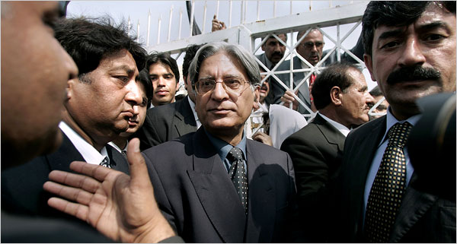
Anjum Naveed/Associated Press
Aitzaz Ahsan, center, the president of the Supreme Court Bar Association, during a protest in Islamabad on Saturday.
RAWALPINDI, Pakistan — Beside racks of hanging meat and barrows of oranges in the alleys of the old town here, Aitzaz Ahsan, leader of the lawyers movement in Pakistan, was back on the campaign trail on Saturday, calling for the release of top justices from house arrest.
Fresh from being released after four months in detention, Mr. Ahsan said the recent parliamentary elections were not enough proof that President Pervez Musharraf’s government was dedicated to democracy. He insisted that the next step had to be the release of the former chief justice, Iftikhar Muhammad Chaudhry, who was fired along with the rest of the Supreme Court during a state of emergency imposed by Mr. Musharraf on Nov. 3. Mr. Chaudhry and nine other justices remain under house arrest.
“Our struggle is to make Pakistan a state where the judiciary is independent, and what Musharraf did to the chief justice is an example of how under him no judge is ever independent,” Mr. Ahsan said to a crowd of lawyers who chanted for Mr. Musharraf’s resignation.
The warmth of the reception for Mr. Ahsan and his rallying cry for Mr. Chaudhry was evident Saturday, with shoppers and storekeepers smiling as they recognized him, stepping up to shake his hand and showering him with pink rose petals.
The rally here on Saturday was part of a series of marketplace demonstrations between the capital, Islamabad, and this nearby city to show support for the chief justice. The lawyers are planning a week of demonstrations on behalf of the justices, called Black Flag Week after the protesters’ flags and armbands. But the rallies, which are also a show against Mr. Musharraf, are sending another message, too: that the lawyers are not willing to take the back seat to their partners in the opposition.
The recent parliamentary elections resulted in a huge victory for the opposition Pakistan Peoples Party, the party of the former prime minister, Benazir Bhutto, who was assassinated. Mr. Ahsan is a senior party member, but is now at loggerheads with the party over the issue of the release of the chief justice and the restoration of an independent judiciary.
Mr. Chaudhry and his family have been stuck inside their home in Islamabad behind barricades of barbed wire and rows of policemen, with only furtive telephone connections to the outside world.
Mr. Ahsan insists that little more is needed to resolve Mr. Chaudhry’s situation than for the police cordon to be removed from around his home. Once that is done, the judge has pledged to walk to the Supreme Court building not far from his house. An executive order could then be written reinstating the chief justice, the lawyers say.
But Asif Ali Zardari, the leader of the Pakistan Peoples Party and the widower of Ms. Bhutto, contends that the restoration of the judiciary and Mr. Chaudhry should be decided by the new Parliament, a far longer process.
Between those positions, the Pakistan Muslim League-N, led by Nawaz Sharif, a former prime minister and an opponent of Mr. Musharraf, argues that a resolution calling for the return of the full bench of judges should be passed by the new Parliament as soon it convenes.
Behind the scenes, the United States is trying to dampen enthusiasm for Mr. Chaudhry, whom Washington sees as too much of a Musharraf opponent.
The United States ambassador, Anne Patterson, met with Mr. Zardari, and suggested that the Supreme Court judges except Mr. Chaudhry should be reinstated, said Shahbaz Sharif, a senior member of the Pakistan Muslim League-N.
In a meeting with Ms. Patterson this week, Tariq Mahmood, a former president of the Supreme Court Bar Association, said he told her that the United States should “appreciate the results of the elections” in which secular political parties received an overwhelming vote.
He said he told the ambassador: “My message was very simple: You love democracy, you live in a democracy, why do you want to deprive us? You are always supporting the dictator.”
Mr. Mahmood said he got the impression that the United States was more concerned with Mr. Musharraf and the fight against terrorism than with an independent judiciary. “As far as the war on terror is concerned, this can be better fought by the parties,” Mr. Mahmood said. “This perception that the Americans have is slightly different to how we are.”
For the past year, Mr. Chaudhry has been a rallying point for the opposition in Pakistan. On March 9 last year, Mr. Musharraf dismissed Mr. Chaudhry, but after a lengthy campaign by lawyers in Pakistan’s major cities and after legal arguments led by Mr. Ahsan, the chief justice was reinstated on July 20.
Then, after a series of judicial decisions that displeased his government, Mr. Musharraf, nervous about how Mr. Chaudhry would rule on the legality of his own October re-election, fired Mr. Chaudhry and the other judges on Nov. 3.
Copyright 2008 The New York Times Company

