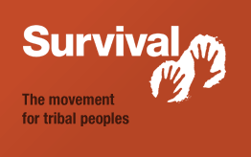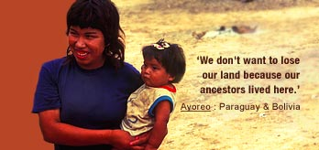

Survival names winner of ‘Greenwashing Award’ 2010 20 January
Survival International
20 January 2010
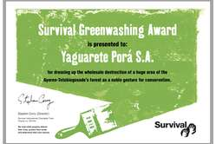
'Survival's 'Greenwashing Award 2010' has been won by ranching company Yaguarete Porá'.
© Survival
A Brazilian company bulldozing an uncontacted tribe’s land in Paraguay has won Survival’s ‘Greenwashing Award 2010’.
The company, Yaguarete Porá S.A., has won the award for ‘dressing up the wholesale destruction of a huge area of the Indians’ forest as a noble gesture for conservation’, says Survival’s director Stephen Corry.
Yaguarete owns 78,549 hectares of forest that is part of the Ayoreo-Totobiegosode tribe’s ancestral territory. After satellite photos were published around the world revealing that it has destroyed thousands of hectares of the tribe’s forest, the company issued a press release announcing it intends to create a ‘nature reserve’ on its land.
But plans submitted by Yaguarete to Paraguay’s Environment Ministry reveal that the amount of ‘continuous forest’ in the reserve will be just 16,784 hectares out of the 78,549 hectares total, and the company in fact plans to convert around two thirds of the land to cattle ranching.
Some of the Totobiegosode have already been contacted and vehemently condemned the plans for the ‘reserve’, pointing out that it violates their rights under both Paraguayan and international law. The contacted Totobiegosode have been claiming legal title to this land since 1993, but most of it is still in private hands.
The Totobiegosode are the only uncontacted Indians in the world having their territory destroyed for beef production.
Survival director, Stephen Corry, said today, ‘This is textbook ‘greenwashing’: bulldoze the forest and then ‘preserve’ a bit of it for PR purposes. The public won’t fall for it. Yaguarete should stop playing games and pull out of the Totobiegosode’s territory once and for all.’
Survival’s Greenwashing Award
Is presented to Yaguarete Porá S.A. for dressing up the wholesale destruction of a huge area of the Ayoreo-Totobiegosode’s forest as a noble gesture for conservation.
The Totobiegosode in numbers:
2,800,000
Estimated hectares of Totobiegosode territory 50 years ago
550,000
Hectares claimed through the courts by the Totobiegosode
78,549
Hectares of Totobiegosode land ‘owned’ by Yaguarete Pora S.A.
57,000
People around the world who have signed a petition in support of the Totobiegosode
16,784
Hectares of ’continuous forest’ planned by Yaguarete for a ‘private nature reserve’ on Totobiegosode land
3,000
Estimated hectares destroyed by Yaguarete in 2009
2,533
Resolution number passed in 2008 by Paraguay’s Environment ministry canceling Yaguarete’s licence to work on Totobiegosode land
169
International law that Yaguarete is violating by working on Totobiegosode land
6
Minimum number of bulldozers operating on Totobiegosode land in recent months
0
Public statements by President Lugo about the Totobiegosode

Act now to help the Ayoreo
Write a letter to the Paraguayan parliament using Survival’s online letter-writing tool.
Donate to the Ayoreo campaign (and other Survival campaigns).
Write a letter to your MP or MEP (UK).
Write to the President, your senators, congressmen or other elected officials (US).
Write to your local Paraguayan embassy (you can find their address through embassiesabroad.com)

© Survival International, 1969–2010 | Registered charity no. 267444 | 501(c)(3) registered nonprofit |
We help tribal peoples defend their lives, protect their lands and determine their own futures.

