Uncontacted tribe pictures provoke public outrage

6 June 2008
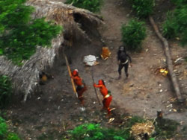
Uncontacted Indians in Brazil seen from the air, May 2008
© Gleison Miranda/FUNAI
Photographs published last week of an uncontacted tribe in Brazil near the Peruvian border have provoked public outrage, with over 1,300 people writing letters to Peru’s government to demand an end to illegal logging. The logging is threatening uncontacted Indians in the area.
The unique pictures of the Brazilian tribe hit the world’s headlines last week. At least one other tribe in the area is thought to have fled over the border from Peru into Brazil, fleeing illegal loggers who are razing their forest home.
Since the pictures were published, the Peruvian government has said it will investigate the issue. Peru’s President Alan Garcia had previously questioned the tribes’ existence.
Survival International is campaigning to support the rights of Peru’s estimated fifteen uncontacted tribes, who are threatened by oil exploration as well as logging.
Survival’s director Stephen Corry said today, ‘These pictures have really struck a chord with people. The uncontacted tribe’s message, with their arrows pointed up at the aeroplane, could not be clearer – they want to be left alone. People understand this, and want to make sure their wishes are respected.’
© 2008 Survival International

