'Don't wipe out uncontacted tribes' say Indians

13 June 2008
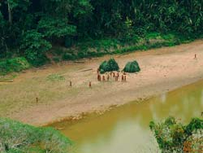
Uncontacted Indians in south-east Peru.
© Heinz Plenge Pardo / Frankfurt Zoological Society
Peru’s Amazon Indian organisation has urged the Peruvian government not to ‘wipe out uncontacted tribes’ living in the remote Peruvian rainforest.
The plea comes just days after the publication of unique photos of an uncontacted tribe in Brazil, near the Peruvian border. At least one other tribe in the area is thought to have fled over the border from Peru to Brazil to escape illegal logging taking place there.
‘Logging is forcing uncontacted tribes out of their own territories,’ the organisation, AIDESEP, says. ‘Don’t wipe them out. AIDESEP urges the Peruvian government to protect the uncontacted tribes and to take immediate and concrete measures to protect their lives and fundamental rights.’
AIDESEP says the logging is taking place in reserves set aside for the uncontacted tribes. The loggers are armed and encounters with the Indians has led to violent conflict, as well as putting them at huge risk because of their lack of immunity to outsiders’ diseases.
© 2008 Survival International

