Company lawyers deny existence of uncontacted tribes

3 July 2008
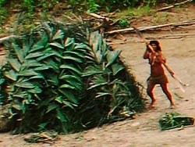
An uncontacted Indian woman in Peru
© Heinz Plenge Pardo / Frankfurt Zoological Society
Lawyers acting for companies wanting to drill for oil on the land of uncontacted Indians have denied that any isolated Indians live in the area.
The denials were made at a court hearing in a case filed by Peru’s Amazon Indian organisation, AIDESEP. AIDESEP is urging the judge to prohibit Perenco and Repsol-YPF from working in ‘Lot 67’ and ‘Lot 39’, large areas of the rainforest where at least two uncontacted tribes live.
But the lawyers have denied the existence of the Indians in these areas, despite the fact that the companies themselves have previously acknowledged them. Barrett Resources, later acquired by Perenco, even attracted fierce criticism from Peruvian Indians after revealing plans to ‘communicate’ with the tribes using megaphones if its oil crews were attacked.
Perenco’s oil find is believed to be the biggest in Peru in thirty years, and the Peruvian president, Alan Garcia, has expressed the hope that it will transform the Peruvian economy.
AIDESEP is also urging the judge to prohibit Peru’s Ministry of Mines and Perupetro from contracting other companies to work in any part of the Peruvian Amazon inhabited by uncontacted tribes. The lawyers did not deny the existence of uncontacted Indians elsewhere in Peru.
A ruling is expected very soon.
© 2008 Survival International

