Washington hears threats to uncontacted tribes

28 October 2008
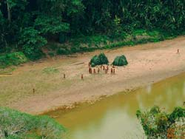
Uncontacted Indians in south-east Peru.
© Heinz Plenge Pardo / Frankfurt Zoological Society
Peru's national Amazon Indian organisation has appeared before the Inter-American Commission on Human Rights (IACHR), based in Washington, to detail the threats facing Peru's uncontacted tribes.
A representative from AIDESEP told the commission about the 'government's erratic policy towards illegal logging, its denial of the uncontacted tribes' existence. . . and the superimposition of the tribes' territories with concessions for oil and gas exploration.'
'Uncontacted tribes really do exist and at the moment they are facing enormous threats to their lives due to oil exploration, gas exploration, and the invasions of colonists and illegal loggers,' said AIDESEP's representative, Saul Puerta Pena.
To read AIDESEP's statement (in Spanish) about the hearing click here.
© 2008 Survival International

