Judge issues statement in uncontacted tribes court case

22 April 2008
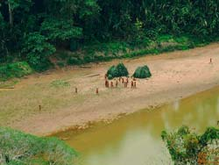
Members of an uncontacted tribe on the Las Piedras river in Peru, seen from the air in 2007.
© Heinz Plenge Pardo / Frankfurt Zoological Society
A judge in Peru has issued a statement dismissing the arguments of three companies and the Peruvian government in a court case involving some of the world’s last uncontacted tribes and oil exploration.
The case was filed by Peru’s Amazon Indian organisation, AIDESEP, in order to ban oil companies from working in regions of the Peruvian Amazon inhabited by uncontacted tribes.
The aim is ‘to protect the fundamental rights to life, health, ethnic identity, clean environment, property and ancestral territories of uncontacted tribes of the Napo/Tigre rivers region – rights that are threatened by the exploration and exploitation of hydrocarbons in Lots 67 and 39,’ a statement from AIDESEP reads.
The companies involved are Repsol-YPF, Barrett Resources (recently acquired by French company Perenco) and Burlington Resources. The companies and the Peruvian government attempted to have the case thrown out of court on various technical points, but the judge has rejected their arguments. A final ruling is expected imminently.
© 2008 Survival International

