
The 2000s: thanks to you, a decade of success
As we enter the new decade, we’d like to thank you for your support for tribal peoples over the last ten years. Here are just a few of the highlights:
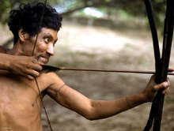 | Land of Awá nomads protected  Following a 20 year Survival campaign, the Brazilian authorities mapped out and legally protected the land of the Awá, one of Brazil’s last nomadic tribes, in 2003. A Brazilian judge ordered this ‘demarcation’ after receiving thousands of letters from Survival supporters. Many Awá have been killed by ranchers’ hitmen, but the recognition of their land gives them a chance of survival. More from the Awa...
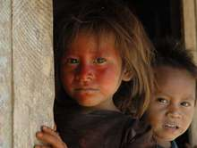 | International law for tribal peoples gains strength  Argentina, Brazil, Chile, Dominica, Nepal, Spain and Venezuela all signed up to the international law for tribal peoples, ILO 169, during the last decade. The total number of signatory countries is now twenty. In Chile, the most recent country to ratify, the law was used in November by the Supreme Court to protect an indigenous group’s right to water. More about ILO 169...
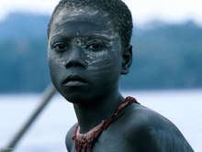 | India recognizes Jarawa’s right to choose future  The Indian government published its new Jarawa Policy in 2004, which recognized the Jarawa tribe’s right to decide their own future. Survival had campaigned vigorously against the government’s 1990s plan forcibly to settle the isolated Jarawa of the Andaman Islands in villages outside their forest, which would have been disastrous for the tribe. More from the Jarawa...
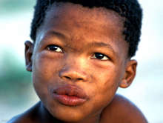 | Kalahari Bushmen win landmark court victory  The Bushmen were evicted from the Central Kalahari in 2002 to make way for future diamond mining. With Survival’s support they fought and won a case in the Botswana High Court in 2006, which affirmed their right to live on their land. Survival’s campaign also targeted De Beers diamond company, which abandoned its project on the Bushmen’s land. More from the Bushmen...
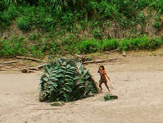 | Peru  The Peruvian government banned oil and gas companies from exploring in some parts of the Peruvian Amazon inhabited by uncontacted tribes, after lobbying from Survival and others. The tribes could have been decimated if exploration had gone ahead. More about isolated Peruvian Indians...

Without the growing movement in support of tribal peoples, none of this would have been possible. Thank you so much for standing with them, and against those who want them to disappear.
Survival International
6 Charterhouse Buildings
LONDON, UK EC1M 7ET
T +44(0)207 687 8700
www.survivalinternational.org

