http://www.hrw.org


Human Rights Watch

Dagestan: A 'Wahhabi' village
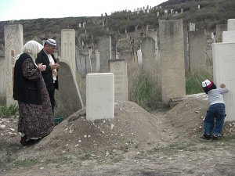
Saidadzhi Saigadzhiev’s mother, brother-in-law and orphaned son next to his grave.
© 2009 Human Rights Watch
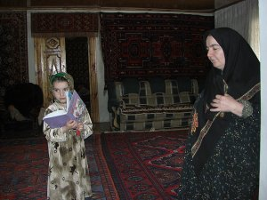
Saigadzhi Saigadzhiev’s widow and daughter.
© 2009 Human Rights Watch
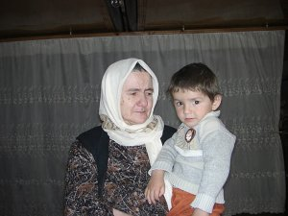
Saigadzhi Saigadzhiev’s mother and youngest child.
© 2009 Human Rights Watch
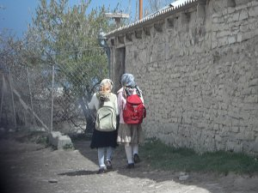
Two girls walking home from school in Gubden.
© 2009 Human Rights Watch
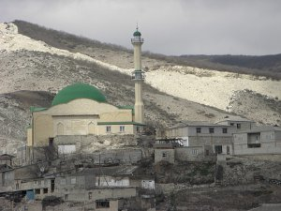
Mosque in Gubden.
© 2009 Human Rights Watch
Related Materials:
Dagestan: curse of the sixth department
Other Material:
«Ваххабитское» село
Later, at the end of the 1990s, talk of these ‘Wahhabis’, some kind of enemy, began, and people were afraid to receive us. Now life has become impossible. I get called a Wahhabi, but I’ve not held a gun since I was in the army. I simply want to follow my beliefs.
by
Tanya Lokshina, Deputy Director of Human Rights Watch's Moscow Office Published on open Democracy News Analysis; originally published on (http://www.polit.ru)
June 3, 2009
There is never a quiet moment in Dagestan. There are all the ‘counterterrorism' operations, when entire houses are destroyed and helicopters fire away into mountain gorges. There are explosions in the streets, and finding bombs that have not gone off yet has become a routine event. Dagestan provides a lot of news, none of it any good. And yet, few people really understand what is happening there. It is hard to get an objective picture of events in such a complex place, home to more than 30 ethnic groups, speaking numerous languages. In fact, it is all but impossible, even more so when the media propagate myths that are often beyond absurd.
***
Gudben is a village with something of a reputation. People outside and inside Dagestan say that this village, in the Karabudakhkent District, is a ‘Wahhabi' nest and have tales aplenty to tell about what goes on there. Listening to them, you get the idea that the village has been completely taken over by Islamists who have all but introduced sharia rule there, almost like in the villages of Karamakhi and Chabanmakhi before the outbreak of the second Chechen war.
The woman are all hidden behind their veils and girls do not go to school, it is said, while the boys study in the Koranic school, where they are turned into future martyrs for Islam. At any rate, so the rumours go, they're ready to take to the forests. Indeed, Islamic "fundamentalism" in Gudben has reached such a degree, people say, that the doors of people's houses have two handles - one for men and one for women. It's not for nothing that a counterterrorism operation has been under way there since March.
Of course, Islam does indeed play an important part in Gudben's life. It is an old village with deep-rooted religious traditions. Even during the Soviet years, local people stubbornly defended their right to believe and pray openly. The Dagestani authorities complained to Moscow that, "in the village of Gudben, in 1956, a group of religious fanatics, acting without permission, opened a mosque", and that "it is very hard to stamp out the relics of the past in people's minds and lives: the religious authorities forbid the young people from joining the Komsomol and constantly undermine communist ideology"
People from Gudben were among the first Russian Muslims to make the hajj in the early 1990s. Salafi preachers were active in the village, and it certainly did have its share of militant Islamists, though there can't have been too many of them, because when Shamil Basayev invaded Dagestan, they were swiftly dealt with by their fellow villagers. The villagers gave them a beating, kicked them out of the madressah and made them promise that they would not under any circumstances help Basayev and his mates. In other words, militancy was not the dominant force in the village.
So, how is it that 10 years later, there is no secular education and even door handles are segregated according to sex? Or is this no more than hearsay?
It's hard to say who thought up the story about the door handles, but the doors in Gudben are exceedingly ordinary, all with just one handle. As for the women, they are not hidden behind burqas, but wear long dresses and cover their hair with a big scarf thrown across the shoulder. You don't see anyone smoking in the streets, and you certainly don't see anyone drunk. People here are serious about their religion, keep the rules, and pray five times a day.
About 12,000 people live in the village, and the local people say that four villagers have gone to join the insurgents in the forest. Just four, not hundreds or even dozens. When the "counterterrorism" operation began in March, the security forces, worried by the news that Gudben had been taken over by "Wahhabi fundamentalists", began identifying families who were not sending their children to school. They came up with a around 30 children who were not receiving any secular education. This is not a good thing, of course, but to put it in perspective, Gudben is not a small village, and most families have many kids, so the number does not seem dramatic. As for the question of education, the real problem is not that there are children who don't go to school, but that even those who do go to school have no chance of getting any decent education there.
Local residents say that the teachers are recent graduates of that very same school, with precious little experience. They speak with the children in the Dargin language, but the textbooks are in Russian. The children learn to read out the syllables, but without actually understanding the meaning of what they're reading. They learn some basic arithmetic, and that is about as far it goes.
The better-off families try to send their boys, especially the older sons, to boarding schools or to relatives in the large towns of Makhachkala, Buinaksk and Kaspiisk. If the boys have their certificates proving that they have nine years of schooling, schools in the towns usually reluctantly accept them into the sixth year and try to help them catch up, though in reality their level is closer to the third year. Village families don't send their daughters away to study. There is not enough money to go around, and they need helping hands at home. Certainly, it is a sad state of affairs, but the same is true of many villages in the North Caucasus.
Gudben is an ordinary village, an old village with narrow winding streets that not every car can manage, but then the streets here were not originally designed for cars. It has picturesque stone houses and a huge cemetery on the hill, from which you get an excellent view of the mosque, the same mosque that Gudben's fearless rebels built against Soviet atheism in the late 1950s. The village women and girls, with their colourful scarves, look exotic to urban-dwelling outsiders.
It is a picturesque Dargin village high up in the mountains, a place with its own customs and traditions. The local life is full of interest. It would be interesting to make a documentary about it and simply portray the daily lives of these people who want nothing but to be left in peace to continue living according to their traditions without the upheaval caused by endless "special operations".
"Young men with beards can't show their faces here", a strongly-built man of around 40 said, shaking his head. "The security people, if they see a beard, that's it -- taken into custody straight away. They don't touch the old people, but a young guy shouldn't better not to go out. People here prayed during the Soviet years. They prayed in secret, but they kept the religion alive. After the old regime collapsed, we started travelling all around Dagestan, preaching Islam, teaching Muslims who had lost their knowledge. We had up to 400 people during the holy Ramadan month. We found mosques that had been turned into storehouses, cleaned them, and people began coming to them again.
"Later, at the end of the 1990s, talk of these ‘Wahhabis', some kind of enemy, began, and people were afraid to receive us. Now life has become impossible. I get called a Wahhabi, but I've not held a gun since I was in the army. I simply want to follow my beliefs. Yes, I practice pure Islam. Muslims need nothing besides the Prophet God sent and what is written in the books. But here we have fundamentalists like me, and traditionalists who follow the sheikhs, and we all pray together, all go to the same mosque. It's shameful to say, but I do not have a beard, though I should, I should be setting an example. But the security people would only cause me problems... Look what happened to Saihadji Saihadjiev. He's the same age as me, not even a young man, and now he's left seven children behind. Who is going to bring them up? Two others were killed along with him. And me, I want to raise my children."
On October 21, 2008, just 10 kilometres away from Gudben, insurgents and security forces clashed. Five police officers, including a local policeman from Gudben, were wounded. The security forces surrounded the village and over four days detained about 40 local people, who were then sent to police stations in Kaspiisk and Makhachkala. There, they were questioned about the insurgents. Many were beaten, threatened, but they were released relatively swiftly.
The villagers thought the incident was over, but on October 27, three Gudben residents, Saihadji Saihadjiev, Nustap Abdurakhmanov, and Akhmed Khadjimagomedov, ‘disappeared'. Forty-four year-old Saihadjiev went that evening to pray at the mosque and did not return home. Hadjimagomedov collected his daughter from school, then went to the mosque, and also disappeared. Abdurakhmanov was in Dagestan's capital, Makhachkala, at that time, and was abducted right there. In all three cases relatives soon found witnesses to confirm that the three men were taken away by law enforcement officials.
On October 28, the families were told that the three men were killed during a "special operation" in Dagestan's Sergokalinsk district, while putting up resistance to law enforcement officers. The families' demands for the bodies were rejected at first. Under Russian law, terrorists' bodies are not handed over to relatives. But Saihadjiev's father turned out to have connections in high-up places and after two difficult days, he and the other two families were able to get back the bodies of their sons and saw clearly that they had been tortured.
Magomed Saihadjiev is 76. Taking his guests up to the second storey of his house, he sits down, upright, his silver-white beard neatly combed. His wife, Kistoman, stays on the stairs, watching attentively but not saying a word, only shedding silent tears from time to time, shyly covering her eyes with the edge of her white headscarf.
"My son left the house and drove to the mosque," Magomed says. "He entered the mosque. There was a white car waiting beside the mosque. When he came out again, the law enforcement people took him away. There were people who saw it happen. We didn't have any real clue about what was going on. There was just this report on the news, this special operation, three insurgents killed, and Saihadji among them. If it weren't for my connections we would never have gotten his body back. He would have been buried somewhere and we would never have known what happened. But they ended up having to hand over his body. When I saw what they'd done to my son... One of my relatives, Abdula Rasudlov, is a doctor. We called him, got him to examine the body and explain what he saw, and we filmed it all on video. I'll put it on for you to watch now."
Magomed puts on the recording. Horrible images of the body are accompanied by the doctor's calm and even voice. Broken bones, burns, bruising...
"We went to the prosecutors. We have a good lawyer too... But there's no hope here. Our lawyer says that if we take the case to the European Court of Human Rights we would definitely win, because we have all the proof. But I heard this would take a long time... Do you know how long we'd have to wait, a year, two years? What, a whole five years? Isn't there any way to speed things up? Please try to do something. You saw yourselves what they did to him? And for what? Saihadji spent his whole life doing nothing but good for others. He never caused anyone any harm. And then there was this shootout with the police, our local policeman got caught in it too, and then they came and took him and the two others away as retribution... Innocent people! He has left four sons behind. How are they going to live now?"
Saihadji's youngest son is 2 years and 8 months old. His relatives say that the boy spends entire days just sitting on the windowsill, waiting for his father, asking when papa will come home.
On the village outskirts, the big cemetery on the hill offers a wonderful view of the mosque, that same mosque that the villagers built without permission more than fifty years ago.
Saihadji is buried near the cemetery fence. His grandmother comes often to the grave with her little grandson. While his grandmother prays, the little boy runs around among the graves, playing hide-and-seek behind the white stone gravestones.
He doesn't yet understand the meaning of death.
Tanya Lokshina
© Copyright 2009 Human Rights Watch

