August 9, 2009

How Russia Defines Genocide Down
By CLIFFORD J. LEVY
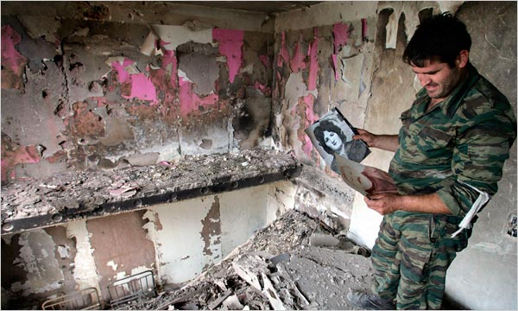
Dmitry Kostyukov/Agence France-Presse — Getty Images
IN RUINS A South Ossetian militiaman returned to his bombed apartment last August.
MOSCOW — After the conflict between Russia and Georgia broke out a year ago, each side accused the other of atrocities, but the Russians went farther. They spoke of marauding Georgian soldiers who systemically killed hundreds if not thousands of civilians in the separatist enclave of South Ossetia. Georgia was guilty not just of war crimes, they said.
It was genocide.
“Eyewitnesses say Georgian army units ran over women and children with their tanks, drove people into houses and burned them alive,” Vladimir V. Putin, the prime minister and former president declared. “What was it if not genocide?”
That word became a Russian rallying cry. But it also served to underscore how the Kremlin seemed to mishandle the campaign to shape public opinion worldwide — a pivotal arena as Russia and Georgia sought to cast blame over who started the fighting.
It was as if senior Russian officials pulled out a dog-eared Soviet propaganda playbook that called for hurling the most outlandish charge, without recognizing that in the modern global media climate, their credibility would quickly suffer if the facts proved otherwise.
In the old days, credibility might not have mattered. Language could be marshaled by the Kremlin in discomfiting ways to advance the ideals of Communism and the West just expected it. But now, Mr. Putin has presented himself and his country as democratic and forward-looking, and that same language is held to a different standard.
And so it was that reporters entered South Ossetia after the five-day war, and Russian and local officials could not explain where all the bodies were, even at one point suggesting that they had been hastily buried by family members in backyards.
It later became clear that the death toll was far lower. The Kremlin now acknowledges that 162 South Ossetian civilians died in the war, out of a population of roughly 70,000. The figure was higher on the Georgian side, with 228 civilians killed, the Georgian government said.
Last week, as Russia used the anniversary of the war to undertake a public relations effort to press its case that Georgia caused it, the genocide charge was largely absent. The Georgian conduct was instead labeled criminal.
(As is customary these days, given that both countries have hired Western public relations agencies, the Georgians issued their own dossier, maintaining that Russia was responsible for the war.)
Asked on Thursday about genocide, a deputy Russian foreign minister, Grigory B. Karasin, seemed to concede that in the turbulent days of last August, the Russian side may have overstepped.
Still, Mr. Karasin emphasized that the allegation had to be understood in the context of regional history, saying that South Ossetians had long believed that the Georgians wanted to exterminate their culture.
“Those people, I think, on an emotional line, not on a legal line, but on an emotional line, have their own right to refer to the policy of Tbilisi toward the minorities, and toward South Ossetians, as a type of genocide,” Mr. Karasin said.
Mr. Karasin did not mention it, but there was another factor. Last August, the Kremlin appeared to jump at the opportunity to turn the tables on the West over the issue of ethnic clashes and breakaway regions.
Russia had long been indignant over Western support for Kosovo, the enclave in Serbia that won recognition as independent last year. The NATO bombing of Serbia in 1999, which was intended to prevent the Serbs from suppressing ethnic Albanians in Kosovo, had especially angered people here.
With the South Ossetian conflict, the Kremlin saw hypocrisy, asking why it was proper for the West to deploy force to support Kosovo in the face of supposed Serbian violence against civilians, but not for Russia to do the same thing for South Ossetia.
The Russians, in other words, ventured that if the West can call the Serbian actions genocide, then the term fit the Georgians as well.
Questioned about the genocide claim five weeks after the war, Russia’s president, Dmitri A. Medvedev, replied with scorn.
“It is laughable when people suggest that we should first count the dead, implying that if there was such and such a number, it would be genocide, but 100 people less and it is not genocide,” Mr. Medvedev said. “Of course, only people who used their aircraft to bomb Yugoslav territory for 90 days could think this way.”
While the Russians have avoided mentioning the word recently, their South Ossetian allies have not entirely done so. Last week, they unveiled a series of exhibits dedicated to the war. They are housed at the Museum of Genocide.
Copyright 2009 The New York Times Company

