Stalin-era mass grave yields tons of bones
by Alexei Chernyshov
10 June 2010

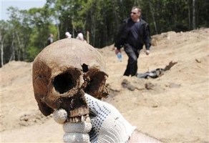
Copyright Reuters

VLADIVOSTOK, Russia (Reuters) - Russia has uncovered at least 495 skeletons, many with head gunshot wounds, in a mass grave probably dating back to purges under Soviet dictator Josef Stalin in the 1930s, municipal authorities said Wednesday.

At least 3.5 tonnes of bones were extracted from the site on the outskirts of the Pacific Ocean port of Vladivostok after it was discovered by workmen building a road, the city government said in a statement.
Millions of Soviet citizens were executed or died in labor camps during Stalin's rule from the 1920s until his death in 1953, but discoveries of mass graves became less frequent after a surge in finds that followed the 1991 Soviet collapse.

Experts were checking the hypothesis that the bodies were victims of Stalin's purges.
"Practically all of the skulls have bullet wounds," said Yaroslav Livanksy, the head of a group of volunteers who helped to excavate the site.

He said money and clothes from the 1930s had been found at the site. A crushed child's skull was discovered close to a bead bracelet and a small slipper.

Irina Fliege, a senior researcher with Russian human rights group Memorial, which collects information about Stalin-era killings, said she had no doubt that the victims were shot by Stalinist forces.
She said far more bodies were likely to be found as adjacent sites are studied.

"This happens all over the country, it's impossible to say how often," Felige said. "All we can to is put up monuments to remember the dead."

Copyright 2010 Reuters

