Rwanda’s genocide history in court

Pierre Pean on trial for revisionism and inciting hatred
Thijs Bouwknegt
25-09-2008
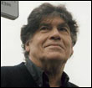
"When he substituted Jew for Tutsi I was immediately reminded of Hitler's Mein Kampf." After these words, French journalist Pierre Pean broke down in tears Wednesday during his trial for inciting hatred against Tutsi's in Rwanda. This week history is debated in court.
Pierre Pean stands accused of inciting racial hatred against Rwandan Tutsi's. Pean's book Noires fureurs, blancs menteurs (Black furies, white liars), released in November 2005, described ethnic Tutsis "as prone to lying and deceit," says French rights group SOS Racisme. On Tuesday they started a case against the 70-year old writer. During the statements by former Jewish student leader Benjamin Abtan, who said that Pean's words " provoked fear among Rwandan genocide survivors", Pean broke down in tears.
SOS Racisme represents IBUKA (Kinyarwanda for Remember), the main organisation of genocide survivors. The group hired French and Belgian lawyers "to take action, at the criminal and civil level, in order to have their rights recognised."
Inciting hatred
Abtan compared Pean with the convicted French Holocaust denier Robert Faurisson: "In my reference book, that emotion can only recall the effect of the name 'Faurisson' on survivors of the Holocaust."
SOS Racisme president Dominique Sopo said that "when you are aware what clinches can trigger in terms of killings, racism and confrontation, especially in that country, it seems to me that this particular issue greatly disturbs those who went through such drama and who prefer not to go through it again".
Genocidal ideology
SOS Racisme accuses Pean of reproducing some of the "prejudices in the genocidal ideology" that led to the slaughter of around 800,000 Tutsis and moderate Hutus in 1994, in the book. Pean wrote that investigating Rwanda is "almost an impossible task given that lies and deceit have been elevated to an art form". He traced this culture back to colonial times: "the first Europeans who had prolonged contact with the Tutsis observed that they were trained in lying," he wrote.
He said it made investigating the Rwanda genocide "an almost impossible task". But on Wednesday, Pean said he "wrote a book on lies, misinformation, which were conducted through extremely elaborate methods, whereby a dictatorial regime wanted people to believe in lies". The author told the judge he considered the court case to be part of a smear campaign orchestrated by the Tutsi-dominated Rwandan government.
"For the past three years, I have been dragged in the mud. I am treated like a racist, at worst a denialist," Pean, who claims to have suffered a heart attack after the charge, told the judge
Rwandan history in court
What happened in Rwanda in 1994 is now fairly common knowledge: the extremely well organised genocide was perpetrated by an extremist ethnic Hutu regime that responded to a military attack by ethnic Tutsi rebels by trying to murder all Tutsi's and moderate Hutu's.
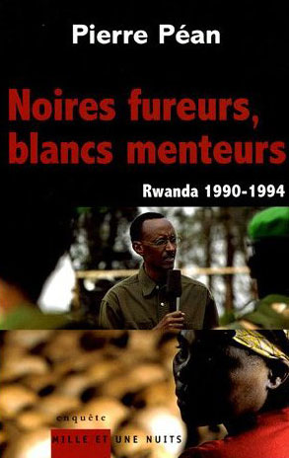
In his book however, Péan alleges the existence of a ‘double-genocide'. He claimed that the real catalyst of the genocide was not the Hutu regime, but the Tutsi rebels who allegedly shot down Hutu President Juvénal Habyarimana's plane on 6 April 1994. This event triggered the genocide. In 2004 the leading French investigating judge, Jean-Louis Bruguière, claimed the assassination was organised by the Tutsi commander, Paul Kagame - the current president of Rwanda. Pean says the "official history" fails to explain the entire story of the killings and that Kagame's regime is responsible for suppressing other versions.
Revisionism
Critics of Pean's book described his work as a revisionist attempt to alter the accepted history of the Rwanda genocide with false comparisons. In his attempt to reinterpret Rwandan history, he was criticised of lacking consistency and credibility. During this weeks hearings in Paris, about 30 historians, other experts and politicians are due to testify on of one of the most violent episodes of the 20th century in an attempt to establish the ‘truth'.
In many European countries it is prohibited to deny the official historical established facts of the Holocaust and, in some countries, the Armenian genocide. Pean's trial might set a precedent for future authors on the genocide to be cautious to doubt historical facts. In Rwanda it is already forbidden to doubt the genocide.
The verdict is expected at a later date.
Copyright 2008 Radio Netherlands Worldwide

