**For Rwandan Students, Ethnic Tensions Lurk  
by Josh Kron, The New York Times  
16 May 2010**

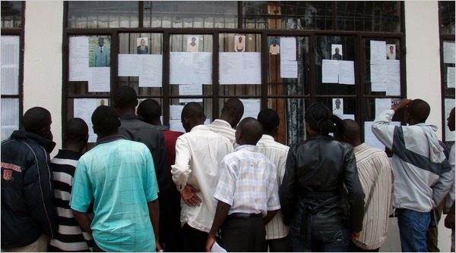

Students at the National University of Rwanda. As elections near, campuses have become tense. (Josh Kron, NYT)

BUTARE, Rwanda — When Eva Mutoni’s boyfriend of three years broke up with her, she realized she should have seen it coming.

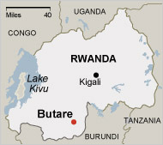

The National University of Rwanda is in Butare.

Ms. Mutoni, 25, whose mother is ethnic Tutsi and whose father is Hutu, and her boyfriend, a full-blooded Tutsi, were college sweethearts at the National University of Rwanda in Butare.

“A year into the relationship, we had a big talk about me being mixed,” she said. They weathered that discussion, aided by the fact that Ms. Mutoni identifies herself as Tutsi. But as they got older, she recalls, his family and some of his friends refused to accept his dating someone of mixed parentage.

“He knew he couldn’t stay with me forever in Rwanda,” she said. “To some, I’m just a Hutu girl.”

Sixteen years after the [Rwandan genocide](http://topics.nytimes.com/top/news/international/countriesandterritories/rwanda/genocide/index.html?inline=nyt-classifier), ethnicity remains an inescapable part of growing up for the young people who will determine the nation’s future. And if the universities, where the government has focused its efforts on building a post-ethnic society, represent the great hope of coexistence, they have so far succeeded only in burying ethnic tensions just beneath the surface.

As presidential elections approach and the nation has grown more repressive, the campuses have become tense. Students say that they are being watched, and that the laws aimed at suppressing ethnic differences have made them afraid to speak openly.

In many ways, college life in Rwanda is no different than it is anywhere else. In hallways and dorm rooms at the elite campus at Butare, the country’s future leaders cope with hormones and final exams, peer pressure and parents. But there is an added element that tends to define all others, what students euphemistically call “ the situation.”

The 1994 genocide, when Hutu death squads massacred hundreds of thousands of minority Tutsis and moderate Hutus, is never far away. At the university, where Hutus and Tutsis live and study side by side, many students are either relatives of the killers or relatives of the victims.

But the Tutsi-dominated government teaches that there are no Hutus or Tutsis, only united, patriotic Rwandans, part of a [reconciliation policy](http://www.nytimes.com/2010/05/01/world/africa/01rwanda.html) enforced by laws criminalizing certain kinds of speech to the contrary.

So the students live in a surreal state of imposed silence, never talking about the one thing always on their minds: each other.

In one way, Feliciano Nshiyimana, a 26-year-old Hutu law student, is a paradigm of President [Paul Kagame](http://topics.nytimes.com/top/reference/timestopics/people/k/paul_kagame/index.html?inline=nyt-per)’s reconciliation efforts. At the crowded and competitive campus, where students sleep four to a room, two to a bed, he shares a bed with a Tutsi genocide survivor. Listening to MP3s on his laptop in his room, surrounded by toiletries, course printouts and posters of the [Manchester United](http://www.manutd.com/) soccer team, he says that conversations among his roommates are delicate, but that they generally get along.

“Background is losing importance,” he said, but added, “If you have an ideology, you hide it.”

While students make acquaintances based on their interests, he says, campus life ultimately divides itself along linguistic lines, and friendships across those lines are rare.

“Linguistic lines,” in this case, is code for the ethnic groups that dare not speak their names. Although the linguistic differences are not cut and dried, for students “French speakers” means Hutu and “English speakers” means Tutsi, specifically those who returned from refugee life in English-speaking Uganda after 1994 and now run the country.

Such code has evolved in the face of the governing party’s efforts to keep peace and power by papering over ethnic identity and pushing a cult of nationalism.

The indoctrination starts before college at [ingando](http://www.law.harvard.edu/students/orgs/hrj/iss18/mgbako.shtml), the solidarity camps most students attend after high school. Among other activities, the campers learn that any problems between Hutus and Tutsis were started by the Belgian colonists, and that Mr. Kagame’s Tutsi rebels were a nationalist liberation movement that committed no significant crimes against humanity when they took over after the genocide.

Colleges have reconciliation clubs, started on government advice ostensibly to combat ethnic hatred, which reinforce the new non-ethnic narrative. Stickers posted on walls urge unity and warn against “divisionism” and “genocide ideology.” Those broadly defined activities have been banned, partly in response to government reports citing high levels of ethnic hatred in the schools. “Stirring up ill feelings” is proscribed by the [genocide ideology](http://www.eurac-network.org/web/uploads/documents/20090924_11845.pdf) ban. Calling a student a name or wearing a T-shirt with the pre-1994 Rwandan flag may be enough to get arrested.

Students say the universities are crawling with spies. In the last year, at least 10 students have been arrested for a wide range of verbal slurs and provocative writing. Six students were arrested last May for damaging a genocide survivor’s clothes. A professor at a college in the east was sentenced to five years in prison last month after one of his students alerted the police that he had insulted Mr. Kagame during class.

At Butare, direct elections for student leadership have been canceled since 2008, when ethnic code words — francophone and anglophone — were deployed in campaigns. The accused students were dismissed, and the student government dissolved.

According to the law, once a student is convicted of genocide ideology, the student can face jail time and will not be readmitted to school, a policy that has students keeping their opinions to themselves.

The ban on genocide ideology also encompasses accusations that the Tutsi rebels killed civilians in 1994, despite the finding by a [United Nations](http://topics.nytimes.com/top/reference/timestopics/organizations/u/united_nations/index.html?inline=nyt-org) research team that the rebels killed up to 45,000 people. A mention of those killings can land a jail term. The genocide, the law says, was committed only against the Tutsis.

The official narrative, students say, amounts to a kind of denial of history. Or as Denise Kajeniri, a 21-year-old Tutsi economics student, describes it, “pretend and move on.”

But the alternative, breaking the wall of silence, remains elusive. Alice Nishimwe, a 23-year-old Hutu studying for her GMATs in Kigali, the capital, says it may simply be too soon to talk.

“Only after talking about our differences can we bridge that gap,” she said. “But that’s individually.” As for the country, she said, “Maybe in my granddaughter’s time.”

*Copyright 2010 The New York Times Company*