Learning from Evil: Reporting in Rwanda
by BBC News
24 May 2010
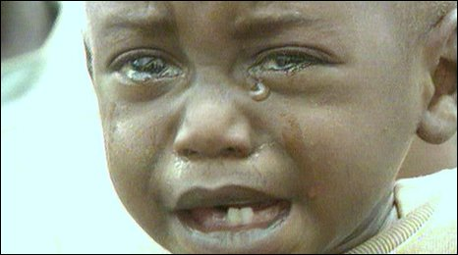
The genocide left Rwanda with countless orphans

Five years ago, BBC Radio Cornwall's Naomi Kennedy, travelled to Rwanda to report on the aftermath of the conflict between the Hutu and Tutsi tribes.
Almost a million people were massacred in a period of just a hundred days in 1994.
The Rwandan genocide erupted on 7 April 1994.
Families, partners and neighbours from the Hutu tribe turned on the minority Tutsi population in the culmination of years of racial hatred.
As part of our Learning from Evil season, we replay Naomi Kennedy's report from Rwanda in 2005 on this page (see link at bottom).
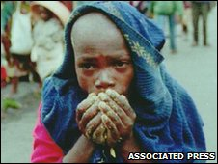
Prior to the colonisation of Rwanda, the Hutu and Tutsi tribes lived closely together. The two tribes speak the same language and follow the same traditions.
However, the Belgium colonisers decided the Tutsi tribe was superior, fuelling conflict between the two tribes.
The genocide was sparked by the death of the Rwandan President Juvenal Habyarimana, a Hutu, when his plane was shot down above Kigali airport on 6 April 1994.
It left a generation of orphans, and many Rwandans suffer to this day from mental trauma and debilitating injuries...
Original text: http://news.bbc.co.uk/local/cornwall/hi/people_and_places/history/newsid_8701000/8701255.stm
Copyright 2010 British Broadcasting Corporation

